REQUEST FOR PROPOSAL

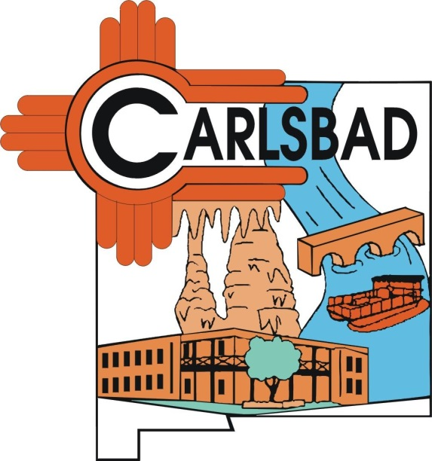

RFP 2019-19

Release Date
September 10, 2019

Contact: Matt Fletcher, Purchasing Manager
Phone – 575-234-7905
Email – msfletcher@cityofcarlsbadnm.com

PROPOSAL DUE DATE: October 25, 2019 by 5:00 PM (MDT)

SUBMIT TO: Purchasing Manager
Carlsbad Municipal Building
101 N. Halagueno Street
Room 115
Carlsbad, NM 88220

Subject: Water available for purchase from the Tatum Wellfield,
owned by the City of Carlsbad

Location: Within the Southern portion of the Ogallala Aquifer,
10 Miles North East of the Double Eagle Well Field in
West Lea County.

(See maps provided on Page 3 and 4)

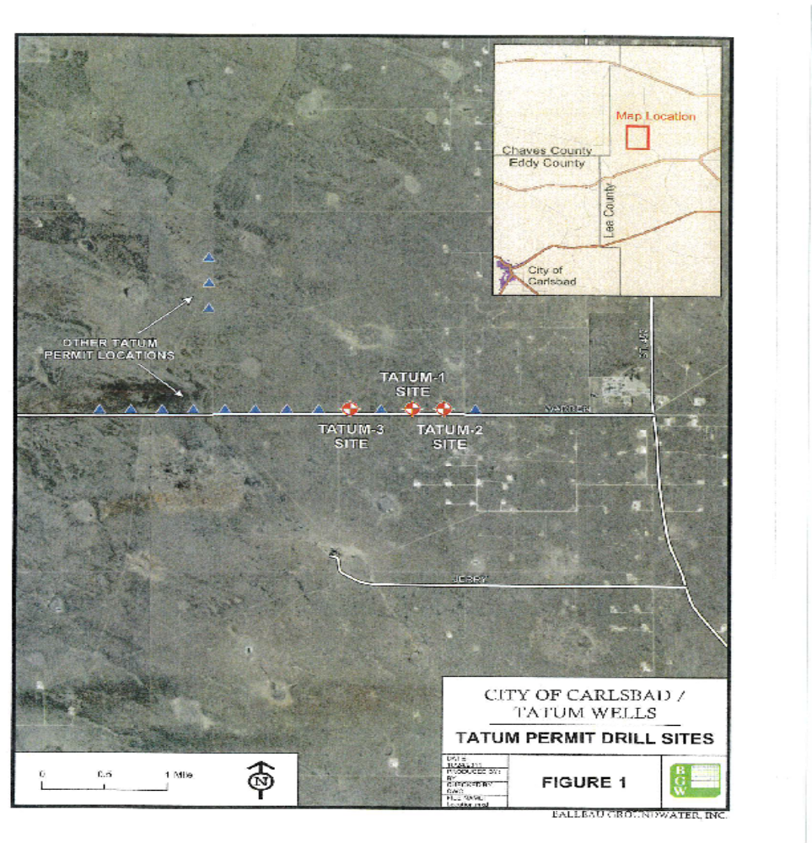

The Ogallala Aquifer, also known as the High Plains Aquifer, is a vast yet shallow underground water table aquifer located beneath the Great Plains in the United States. It is one of the world's largest aquifers and covers an area in portions of eight states, which include Colorado, South Dakota, Nebraska, Wyoming, Kansas, Oklahoma,
Texas, and New Mexico..
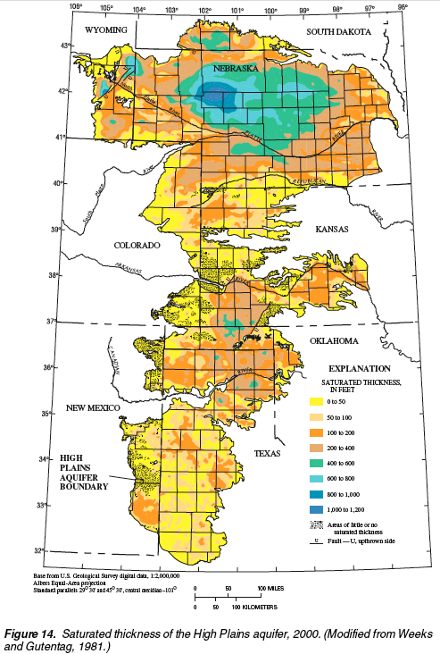
PURPOSE

The City is seeking proposals from parties interested in entering into an agreement with the City to purchase water from the City’s Tatum Water Wells.

The City maintains 3 drilled and completed water wells, each capable of producing up to 250 gallons per minute of non-potable water.

The City currently has no infrastructure to transfer the water to the Double Eagle pipeline system. Therefore, the City intends to use the revenue gained from the sale of the water resource to private enterprise or individuals to fund a future pipeline to connect the Tatum Wells to the Double Eagle system for transport to the City water system.

TERMS AND CONDITIONS

1. The term of the agreement shall be 5 years

2. The City will pump the non-potable water to the surface.

3. The quality, quantity and availability of water will not be
guaranteed by the City.

3. Each well will be metered by the City at the wellhead.

4. The customer will provide the necessary infrastructure and
equipment for the extraction and transport of the water.

5. Payments shall be made to the City on a monthly basis
according to metered usage data collected by the City.

6. The customer agrees to indemnify, save, and hold harmless,
the City, its officers, and employees against all liability,
claims, damages, losses, or expenses of every kind,
including reasonable attorneys’ fees together with costs and
expenses of litigation, arising out of, from, or associated in
any manner with the acts or omissions of the customer, its
officers, agents, or employees. A certificate of liability
insurance in the minimum amount of $1 million shall be
provided with the proposal and must be maintained
throughout the duration of the agreement.

7. The agreement may be terminated by either party with
written 90 day notice.

SUBMITTAL OF PROPOSALS

Proposals shall include the following:

1. Financial Assurance in the form of most recent financial
statements, or letter or credit from a financial institution.

2. Proposal shall include a detailed plan describing the means for
extraction and transportation of the sold water.

3. Cost proposal to include the price per barrel the customer is
willing to pay for the water use rights.

- Offers shall be submitted in a sealed envelope to the Purchasing Manager, Room 114, Municipal Building, 101 N. Halagueno, Carlsbad, NM 88220 by 5:00 p.m. (MDT) on or before October 25, 2019. Proposals sent by email or fax will not be accepted.

- The City will consider offers that are in the best interest of the City and has the right to reject any and all offers.

Offer Form
RFP 2019-19

By signing this form, the offeror agrees to all terms and conditions as described in items 1 – 7.

Any exceptions taken to these terms should be detailed and provided with the offer submitted. Attach additional pages if necessary.

Offer Submitted by: ____________________________
Company Name

Individual Representing Company _____________________
Printed Name

Offer Price per barrel $ ____________________

Additional Conditions to Offer (if any) ____________________________________________________________________________________________________________________________________________________________________________________________________________________________________________________________________

Exceptions to terms (if any) : ____________________________________________________________________________________________________________________________________________________________________________________

Signature __________________ Date: __________

