Advance Tabco FS-1-3024-24 Spec Line Fabricated One Compartment Pot Skink with One Drainboard -56½”
*Drainboard left side only*
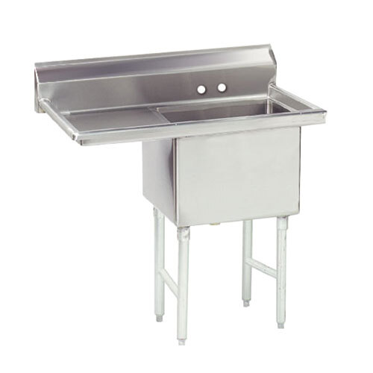

Regency 24” x 72” 16- Gauge Stainless Steel Commercial Work Table with 4” Backsplash and Undershelf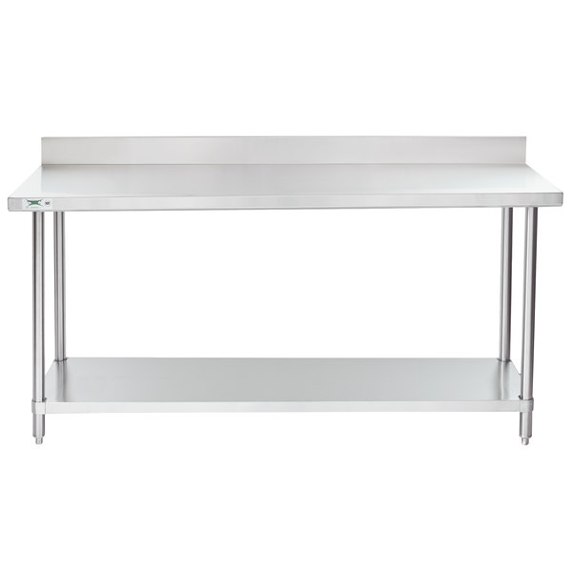

Regency-30-x-24-18 Gauge 304 Stainless Steel Equipment Filler Table with Backsplash and Galvanized Undershelf
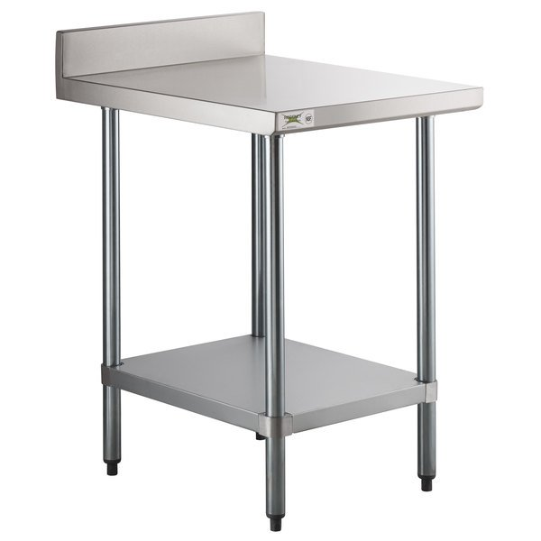
Regency 15” x 24” 18 Gauge 304 Stainless Steel Equipment Filler Table with Backsplash and Galvanized Undershelf
Similar to the above picture

Regency 24” x 24” Stainless Steel Microwave Shelf
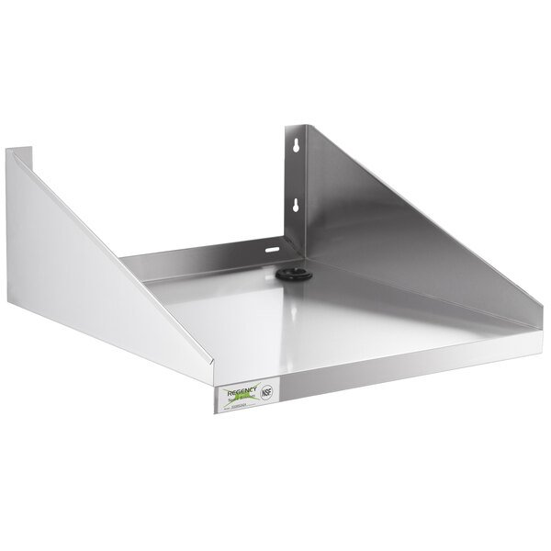

Regency 1.15 GPM Wall Mount Pre-Rinse Faucet with 12” Add-On Faucet and 8” Centers
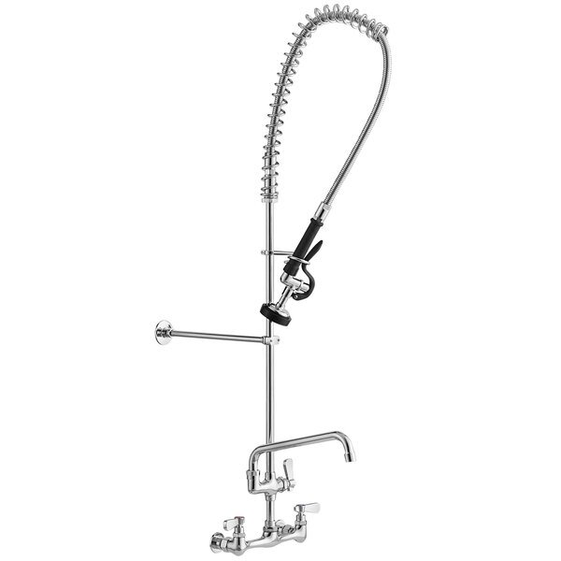

Regency 20” x 20” x 5” Drawer with Stainless Steel Front
Quantity of 2
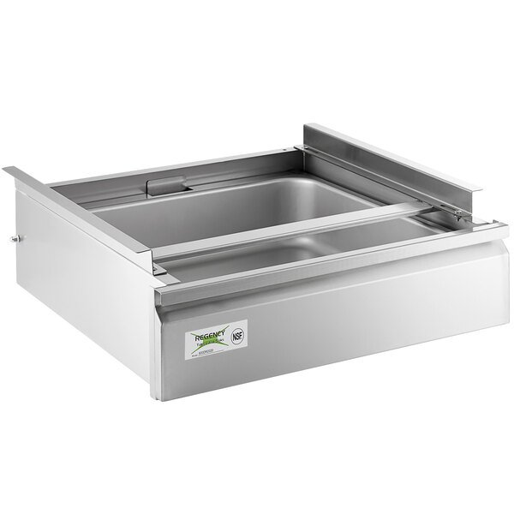

Equip by T & S 5GF-W-F Wall Mounted Push Back Glass Filler – 3/8” NPT Female Inlet.
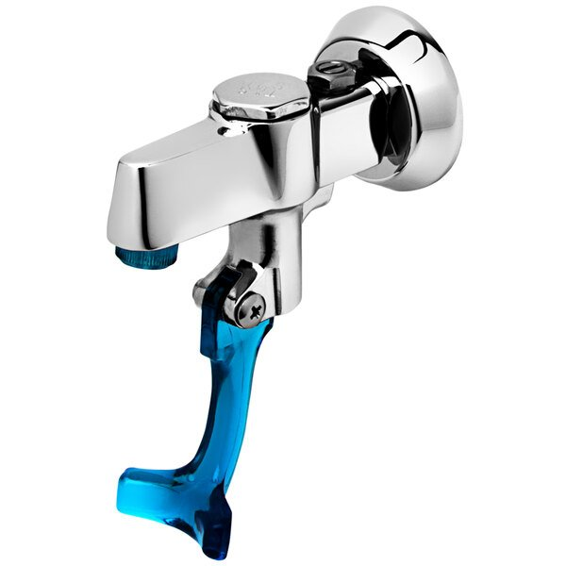

Regency 16 Gauge Stainless Steel 12” x 72” Heavy Duty Solid Wall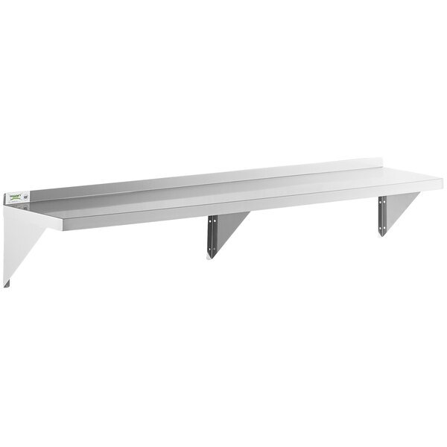

Regency 16 Gauge Stainless Steel 12” x 60” Heavy Duty Solid Wall Shelf
Pictured above
Regency 16 Gauge Stainless Steel 12” x 84” Heavy Duty Solid Wall Shelf
Pictured above
Quantity 2

15” Crescent Ice Maker BI98
Dimensions Depth: 20”, Height 27 3/8”, 14 15/16” ***Dimension Cannot Exceed***
