Request for Proposals

Project Based Vouchers

Solicitation Number | Q2010
Due Date | KCDC will accept proposals until 11:00 a.m. on August 21, 2019.
Deliver Responses to: | Knoxville’s Community Development Corporation  Procurement Division  901 N. Broadway  Knoxville, TN 37917  Procurement is in a separate building behind the main office building
Electronic Copies: | Suppliers are encouraged to use the MS Word version to provide a typed response. Electronic copies are available on KCDC’s webpage or by emailing purchasinginfo@kcdc.org.
May responses be emailed to KCDC | ☐ Yes ☒ No
Questions About This Solicitation | Submit questions to purchasinginfo@kcdc.org

Check KCDC’s webpage for addenda and changes before submitting your responses

General Information

- Background and Intent

a. Knoxville's Community Development Corporation (KCDC) is the public housing and redevelopment agency for the City of Knoxville and for the County of Knox in Tennessee. In addition to operating its public housing apartments, KCDC oversees approximately 4,026 Section 8 Vouchers and 82 Moderate Rehabilitation units.

b. This RFP is pursuant to Title 24, Part 983 of the Code of Federal Regulations Project Based Voucher program and Section 3 of the KCDC Housing Choice Voucher (HCV) Administrative Plan. Only those proposals that further KCDC’s mission and preserve existing affordable housing or create new affordable housing within Knoxville, Knox County will be considered.

c. KCDC is seeking to award up to 150 Section 8 Project-Based Vouchers (PBVs) for Existing, New or Rehabbed housing units to promote affordable housing opportunities for persons in the City of Knoxville and/or Knox County.

d. Under the PBV program, HUD allows PHAs to attach up to 20% of its Section 8 Housing Choice Voucher program units to specific housing units. The housing subsidy will remain connected to the units after a tenant moves out of the unit. The owner must agree to rent the unit to eligible tenants for the duration of the Housing Assistance Payments (HAP) contract, which may range from 10- 20 years.

e. This RFP solicits the participation of owners who request PBV assistance for Existing, Rehabilitated or New constructed units. KCDC may select multiple projects under this RFP so long as the total number of vouchers committed does not exceed 150.

f. KCDC will accept proposals through August 21, 2019 or until the issuance of up to 150 vouchers. KCDC will conduct evaluation of proposals received. KCDC may reject any or all proposals and terminate the RFP process at any time if deemed by KCDC to be in its best interest.

g. Activities under the PBV program are subject to HUD environmental regulations in 24 CFR parts 50 and 58. Under 24 CFR, part 58, a unit of general local government, a county or a state (the “responsible entity” or “RE”) is responsible for the federal environment review under the National Environmental Policy Act of 1969 (42 U.S.C. 4321 et seq.) and related applicable federal laws and authorities in accordance with 24 CFR 58.5 and 58.6.

i. Subject to funding availability, the initial term of the proposed contract(s) is not less than 10 years and not more than 20 years, with an option at KCDC’s discretion, to extend the contract(s) up to an additional 20 years.

j. KCDC will establish a Project Based Voucher waiting list once selection of one or more properties have been selected in response to this RFP. Selection from the waiting list will be in accordance with the Section 8 Administrative Plan. The Section 8 Administrative Plan is located at: http://www.kcdc.org/housing/section-8/ .
k. KCDC intends for this solicitation to result in the selection of one or more property owners in Knoxville and/or Knox County to provide affordable housing. Project Based Voucher (PBV) assistance provides rental subsidies paid on behalf of eligible families who live in units contracted under the program. This RFP seeks proposals from owners/developers who will commit the greater of 25 units in a project or 25 percent of the units in a project through project based vouchers . See paragraph 13C-2 for additional details about excepted units.

To maximize the supply of safe, decent and affordable housing for chronically homeless persons as identified in The Knoxville’s Plan to Address Homelessness, KCDC will provide Project-Based Vouchers (PBV) for selected New, Rehabilitated or Existing housing developments willing to designate a portion of the units to chronically homeless persons. KCDC also will provide Project Based Vouchers (PBV) for Elderly Housing designated as Independent Living with supportive services. HUD defines PBV existing housing developments as housing units that already exist and that (upon KCDC inspection) substantially comply with the Housing Quality Standards (HQS) on the proposal selection date.

In accordance with the PBV Program regulations, 24 CFR Section 983.56 (b), KCDC will enter into a Housing Assistance Payments (HAP) Contract (Attachments) with selected property owner(s) for designated rental units for chronically homeless persons or designated rental units for elderly units designated as independent living with supportive services. The HAP contract establishes the initial rents for the units and describes the responsibilities of KCDC and the owner. KCDC will pay rental assistance (based on each household’s income) to the owner of rental units that meet PBV program standards and are occupied by eligible families. The initial term of the HAP contract may be up to 20 years. HAP contract renewal after the initial term may occur at the sole option of KCDC for a period (not exceeding 20 years) as KCDC determines appropriate to expand housing opportunities and to achieve long-term affordability of assisted housing for chronically homeless persons and elderly independent living with supportive services. All HAP contracts and subsequent renewals are contingent upon the future availability of appropriated HUD funds for the KCDC Housing Choice Voucher Program.

This RFP seeks proposals that meet the criteria for an exception to the 25% cap on number of PBV units in each building by providing supportive services in multi-family buildings specifically made available for Qualifying Families defined as:

1. Elderly or disabled families; or
2. Families receiving or eligible for qualifying supportive services
3. Elderly independent living with supportive services

l. The Project-Based Voucher (PBV) Program regulations are set forth in Code of Federal Regulations, Title 24, Part 983. A copy of the regulations is available at: https://www.hud.gov/program_offices/public_indian_housing/programs/hcv/project

m. KCDC will not execute a HAP contract or an AHAP until all required reviews are completed.

2. Changes After Award
It is possible that after award KCDC will need to revise the service needs or requirements specified in this document. KCDC reserves the right to make such changes after consultation with the proposer.

3. Contact Policy
Only contact KCDC’s Procurement Division about this solicitation from the issuance of this RFP until award. Information obtained from an unauthorized officer, agent, or employee will not affect the risks or obligations assumed by the proposer or relieve the proposer from fulfilling any of the conditions of the resulting award for the purpose of this project. Such contact can disqualify the proposer from the solicitation process.

4. Copies
The proposer will deliver 3 copies and 1 original (so marked) of your proposal. Additionally, the proposer will submit a flash drive containing the proposal.

5. Definitions

a. Existing Housing: Units built on or before the date of the project selection, have a valid certificate of occupancy. The units must fully comply with HQS before execution of the HAP Contract.

b. Rehabilitated Housing: Housing units developed pursuant to an Agreement between KCDC and the owner for use under the Project-Based Voucher (PBV) program and exist on the proposal selection date, but do not substantially comply with HQS on that date. Or these are units that use PBV as a means to finance $10,000 or more of rehabilitation per unit.

c. Newly Constructed Housing: Creation or rehabilitation of new affordable housing units of at least $10,000 per unit that do not exist on the proposal selection date and are developed after the date of selection pursuant to an Agreement between the PHA and the owner for use under the PBV program.

d. Housing Quality Standards (HQS): The HUD minimum quality standards for housing assisted under the Housing Choice Voucher program listed at 24 CFR 982.401 or any subsequent standards adopted by HUD.

6. Errors and Deficiencies
The successful proposer will revise any material errors under an agreement resulting from this RFP without additional compensation if it is determined that the proposer is responsible for errors or deficiencies.

7. Evaluation

a. All responses are subject to a determination of “responsive” and “responsible” prior to award. KCDC is the sole judge as to proposer “responsiveness” and “responsibility.”

b. KCDC reserves the right to request additional information to assist in the evaluation process. This includes references and business capacity information.

c. KCDC will evaluate responses with a weighted evaluation system. The categories and points assigned for each category are:

FACTORS | MAXIMUM POINTS
Staff and Project Team Qualifications | 20
Housing Management Experience & Knowledge of State/Federal Low Income Housing Programs | 25
Creation of new affordable housing or rehabilitation of $10,000 per unit | 30
PBV Plan | 25
Total Points Possible | 100

d. KCDC will review all proposals properly submitted. KCDC reserves the right to request necessary modifications, waive minor technicalities, reject all proposals, reject any proposal that does not meet mandatory requirement(s) or cancel this RFP, according to KCDC’s best interests.

e. KCDC’s Evaluation Team may elect to interview proposers before making an award.

f. KCDC’s Evaluation Team may elect to first rank proposals with a simple numeric score and then detail only the top tier of proposals.

g. KCDC reserves the right to waive technical irregularities in submissions or to reject any or all proposals if to do so is in the best interest of KCDC.

h. All materials submitted pursuant to this RFP become KCDC’s property.

i. KCDC reserves the right to use all pertinent information (also learned from sources other than disclosed in the RFP process) that affect KCDC’s judgment as to the appropriateness of an award to the best evaluated proposer.

j. If there are not enough project-based vouchers available to fully fund a proposal, KCDC may offer proposers the opportunity to accept a lesser number of vouchers than requested or to decline all vouchers.

8. General Instructions
KCDC does not insert “General Instructions to Suppliers” in the solicitation document. These instructions are at www.kcdc.org. Click on “Procurement” and follow the link. By submitting a response to this solicitation, the supplier accepts the responsibility for downloading, reading and abiding by the terms and conditions set forth in KCDC’s “General Instructions to Suppliers.” Suppliers may wish to review certain applicable HUD instructions on KCDC’s webpage.

9. Proposer’s Representation
The proposer represents and warrants that it is:

a. Familiar with all pertinent federal, state, municipal and county laws, ordinances and regulations, which may in any way affect the operation and management of affordable housing; and

b. Financially solvent; and

c. Experienced in and competent to perform affordable housing management in compliance with all regulations applicable to affordable housing with supportive services.

10. Questions
Direct questions pertaining to this document to purchasinginfo@KCDC.org with “Project Based Vouchers” in the subject line. Proposers will allow at least 5 calendar days for KCDC to respond with an answer.

11. Section 3 of the Hud Act of 1968
Section 3 is a provision of the Housing and Urban Development Act of 1968, which requires that programs of direct financial assistance administered by the U.S. Department of Housing and Urban Development (HUD) provide, to the greatest extent feasible, opportunities for job training and employment to lower income residents in connection with projects in their neighborhoods. Further, to the greatest extent feasible, contracts in connection with these projects are to be awarded to local businesses. Section 3 is a tool for fostering local economic development, neighborhood economic improvement and individual self-sufficiency.

a. Recipients and vendors must make a good faith effort to utilize Section 3 area residents as trainees and employees in connection with the project. Targeted recruitment and the selection of Section 3 area residents for available positions are two examples of good faith efforts to meet this requirement.

b. Recipients and vendors must make a good faith effort to award contracts to Section 3 business concerns for work in connection with the project. An example of a good faith effort to meet this requirement is the implementation of an affirmative action plan, which includes targets for the number and dollar value for awarding contracts to Section 3 business concerns.

c. Recipients and vendors must keep records and submit reports to HUD documenting the good faith efforts taken and the results of these actions. Examples of such documentation include letters to community organizations, employment development and business development centers, copies of solicitations for proposals or proposals; and copies of affirmative action plans.

d. How can businesses find Section 3 residents to work for them? By recruiting in the neighborhood and public housing developments to tell about available training and job opportunities. Distributing flyers, posting signs, placing ads, and contacting resident organizations and local community development and employment agencies to find potential workers are a few effective ways of getting jobs and people together.

e. All contracts awarded are subject to Section 3 requirements. Proposer will seek to fill any and all position that are needed and unfilled with residents of KCDC communities. For additional information, please go to http://www.hud.gov/offices/fheo/section3/Section3.pdf . The successful proposer will supply KCDC with job announcements for any position that must be filled as a result of the award of KCDC work. Additionally the successful proposer will supply the same job announcement to the Knoxville-Knox County Committee Action Committee’s Workforce Connections group. These can be faxed to 544-5269.

f. A Section 3 resident is one who lives within a public housing authority’s apartment. It is also people who live in an area with a HUD assisted program and whose income is below HUD’s low income requirements.

g. A Section 3 business is one that:

1. Is at least 51% owned by a Section 3 resident; or

2. Employs Section 3 residents for at least 30% of its employee base; or

3. Makes a commitment to sub award at least 25% of the project’s dollars to a Section 3 business.

Scope of Work

12. General
This solicitation’s intent is to maximize the supply of affordable housing in Knoxville/Knox County. KCDC will provide Project-Based Vouchers (PBV) for selected existing housing developments willing to designate a portion of their units or with rehabilitation of existing units or creation of new housing units.

In accordance with the PBV Program regulations, 24 CFR Section 983.56 (b), KCDC will enter into a Housing Assistance Payments (HAP) Contract (Attachments) with selected property owner(s) for designated rental units. The HAP contract establishes the initial rents for the units and describes the responsibilities of KCDC and the owner. KCDC will pay rental assistance (based on each household’s income) to the owner of rental units that meet PBV program standards and are occupied by eligible families. The initial term of the HAP contract may be up to 20 years but not less than 10 years. HAP contract renewal after the initial term may occur at the sole option of KCDC for a period (not exceeding 20 years) as KCDC determines appropriate to expand housing opportunities and to achieve long-term affordability of assisted housing. All HAP contracts and subsequent renewals are contingent upon the future availability of appropriated HUD funds for the KCDC Housing Choice Voucher Program.

KCDC will consider Newly Constructed units which are units that do not exist on the proposal selection date and are developed after the date of selection for use under the PBV program for their proposal. KCDC will consider Rehabilitated Housing units for this proposal as well. Rehabilitated Housing units are units that exist on the proposal selection date but that do not comply with Housing Quality Standards on that date and are developed, per an agreement between the owner and KCDC, for use under the PBV program. KCDC will enter into an “Agreement to Enter into a Housing Assistance Payment (AHAP) Contract. KCDC will consider Existing units which is defined as housing that substantially meets Housing Quality Standards (HQS) on the date of the proposed selection. KCDC and the owner will enter into a Project Based Voucher Housing Assistance Payment (HAP) Contract after approval from the RFP and all units pass Housing Quality Standards (HQS.)

13. Project-Based Voucher Program Overview

a. A PHA that already administers the tenant-based voucher program has the discretion to operate a PBV program. The PBV program is funded with a portion of the appropriated funding available under the PHA’s tenant-based voucher program. There is no special or additional funding for project-based vouchers. In the PBV program, the assistance is “attached to the unit” rather than the tenant. Certain types of housing units and/or developments are not eligible for PBV assistance including:

- Shared housing

- Units on the grounds of a penal, reformatory, medical, mental, or similar public or private
institution

- Nursing homes or facilities providing continuous psychiatric, medical, nursing service, board and
care, or intermediate care. However, KCDC may approve assistance for a dwelling unit in an assisted living facility that provides home health care service such as nursing and therapy for residents of the housing

- Units that are owned or controlled by an educational institution or its affiliate and designed for
occupancy by the students of the institution

- Manufactured homes

- Cooperative housing

- Transitional housing

- High-rise elevator projects for families with children

- Owner-occupied housing units

- Units occupied by an ineligible family at the time of proposal submission or prior to execution of
the Housing Assistance Payment (HAP) contract

- Subsidized housing unit types determined ineligible in accordance with HUD regulations. These
include, but are not limited to:

- Public housing units

- Units subsidized with any other form of Section 8 assistance

- Units subsidized with any governmental subsidy that covers all or part of the operating costs
of the housing; units subsidized with rental assistance under Section 236, Section 521 or Section 101 units subsidized under Section 202 including supportive housing for the elderly

- Units subsidized under Section 811

- Units subsidized with any form of tenant-based rental assistance as defined by 24 CFR
982.1(b)(2) including units subsidized with such assistance under the HOME program

- Units with any other duplicative federal, state or local housing subsidy as determined by HUD
or KCDC

b. Relocation Requirements (24 CFR 983.7): Any persons displaced as a result of implementation of
the PBV program must be provided relocation assistance in accordance with the requirements of the Uniform Relocation Assistance and Real Property Acquisition Policies Act of 1970 (URA) (42 U.S.C. 4201-4655) and implementing regulations at 49 CFR part 24. The cost of required relocation assistance is responsibility of the owner.

c. This RFP seeks proposals that meet the criteria for an exception to the 25 percent cap on number of PBV units in each building by providing supportive services in multi-family buildings specifically made available for Qualifying Families defined as:

- Elderly or disabled families; or
- Families receiving qualifying supportive services as defined below
- Elderly Independent Living designated units with supportive services

Apart from Excepted Units, KCDC may not select a proposal to provide PBV assistance or enter into an Agreement or HAP contract for more than 25% of the number of dwelling units (assisted or unassisted) in the building. The exception allowed for Excepted Units for qualifying families as provided for are:

(1) Units in a single-family building;

(2) Units in a multi-family building that are “excepted units” specifically made available for Qualifying
Families defined as:

a. Elderly or disabled families; or

b. Families receiving or eligible for qualifying supportive services as defined in the RFP.

c. Elderly Independent Living designated units with supportive services

d. Supportive Services Requirements: For Excepted Units for occupancy by a Qualifying Family, the selected proposer(s) must:

(1) Provide, on a regular basis, services by qualified providers targeted to the needs of the
Qualifying Family; and

(2) Locate at least one qualified case manager onsite or offsite, and

(3) Provide a qualified service provider to respond to emergency supportive services needs
twenty-four hours per day, seven days per week.

e. Qualifying Supportive Services: At least one member of the Qualifying Family must receive, qualify to receive or be offered one or more of the following Qualifying Supportive Services as agreed to in the family responsibility statement. Medical or disability-related services must be available but KCDC will not require a Qualifying Family to participate in such services other than drug and alcohol treatment in the case of current abusers. Required Qualifying Supportive Services include:

(1) Case management services

(2) Mental health services

(3) Medical and dental care

(4) Substance abuse counseling and treatment

(5) Household management training, such as housekeeping skills and money management

(6) Job training and employment services, such as preparation and counseling, training, job development and placement, follow-up assistance after job placement.

(7) Educational or vocational services, such as literacy courses, vocational training, courses to complete secondary or postsecondary school.

f. Monitoring of Qualifying Supportive Services: KCDC will monitor Qualifying Supportive Services on an annual basis. Such monitoring will include:

(1) Review of agreements with property owner(s) and/or service providers that include recordkeeping and reporting obligations; and

(2) Personal interviews with property owner(s) and/or service providers and members of families receiving Qualifying Supportive Services; and

(3) Other appropriate means of monitoring.

g. Statement of Family Responsibility: At the time of initial lease execution, a family receiving Qualifying Supportive Services will be asked to enter into a Statement of Family Responsibility or other appropriate agreement with the property owner(s) and/or supportive service provider with KCDC as a subsidiary party. The agreement must state the family is eligible to participate in one or more Qualifying Supportive Services and achieve certain goals specified in the agreement.

(1) Completion of Services Obligation: If a family receiving Qualifying Supportive Services successfully continues its supportive services obligation, the family may continue to reside in the excepted unit provided the family continues to comply with other obligations under the PBV Program. In such case, the unit continues to count as an excepted unit.
(2) Termination for Failure to Fulfill Services Obligation: If a family receiving Qualifying Supportive Services fails, without good cause, to complete its supportive services obligation, KCDC will terminate rental assistance for the family and the family will be required to vacate the unit within the time established by KCDC. If the property owner terminates the family’s lease and rents the vacated unit to a Qualifying Family, the unit will continue to count as an excepted unit.

h. Proposed projects must be able to meet all the HUD requirements of the Project-Based voucher program under 24 CFR 983, including but not limited to applicable environmental review requirements (see https://www.hudexchange.info/programs/environmental-review/ ), prevailing wage requirement and subsidy layering requirements (see https://www.gpo.gov/fdsys/pkg/FR-2014-09-26/pdf/2014-22971.pdf ). Applicants must become familiar with these requirements.

i. If a project requiring a waiver from HUD does not receive the waiver, the project will not be considered unless the applicant can change their proposal to meet the HUD requirements. If this change would alter the ranking points assigned to the application, KCDC will re-score and rank the proposal.

j. For a project to be eligible to receive project-based vouchers, it must meet the threshold items listed below. If the project fails to meet any of the items listed, the proposal is non-responsive.

- The property must be located within Knoxville and/or Knox County.

- The minimum project size is 20 units. KCDC may waive this requirement if there are an insufficient
number of units to reach up to 150 units in the proposals received. Projects may be one or more buildings on a single site, or multiple sites that are or will be under common ownership, management and financing.

- Owner/Developer must demonstrate site control as evidenced by deed, sales contract, or option
agreement.

- Owner/Developer, including its principals, member(s), and contractors, must be current in all
financial obligations to KCDC. KCDC will not award funds to an organization or agency with outstanding disallowed costs, defaulted loans, debarment actions, and/or is behind schedule on any currently KCDC-funded project, or any other legal encumbrances.

14. Property Management/Leasing
The property owner(s) selected to receive PBVs are responsible for oversight of property management to ensure compliance with PBV regulations, federal, state, municipal and county laws, ordinances and regulations that may, in any way, affect the operation and management of affordable housing. KCDC’s Section 8 Program will maintain a waiting list for occupancy of a unit assisted under the PBV Program. Owners of PBV properties may maintain a site-based waiting list of families for referral to KCDC for eligibility determination and placement on the PBV waiting list. An applicant may choose to be simultaneously listed on the PBV project waiting list as well as the KCDC tenant-based waiting list if eligible.
The Section 8 Program Administrative Plan applies to managing the waiting list and selection of applicants from the waiting list to fill vacancies at the PBV properties. KCDC's published subsidy standards will determine the appropriate unit size for the family based on family composition.

15. Property Standards
All properties must meet the following standards:

a. The project must meet all applicable state and local codes, rehabilitation standards (if applicable) and ordinances.

b. The project must meet the accessibility requirements of the Fair Housing Act and, for rehabilitation projects, Section 504 of the Rehabilitation Act of 1973 (See Exhibit 3).

c. The project must meet minimum HUD housing quality standards or subsequent standards adopted by HUD.

16. Other Federal Requirements
Other federal requirements may also apply. These include:

- Davis-Bacon Requirements
The Davis-Bacon Act applies to every contract for construction of housing (new or rehabilitation) that consists of nine or more units assisted.

- Environmental Review Requirements (See Exhibit 1)
New Construction and Substantially Rehabilitated Projects receiving an award are subject to environmental review. Work may not be undertaken, including work undertaken with other sources of funds, or funds committed or expended (federal or other) effective when Owner/Developer submits its proposal to KCDC until KCDC executes an Agreement to Enter into a Housing Assistance Payments (AHAP) Contract.

- Fair Housing and Equal Opportunity

- Lead-Based Paint (24 CFR part 35, subparts A, B, J, and R)

- Uniform Relocation Act (if applicable)

- Section 504 Requirements (See Exhibit 3)

- Subsidy Layering Review Requirements (See Exhibit 4)

- 24 CFR-part 983.57 (d) and (e) (Posted on KCDC’s webpage)

17. Submittal Structure Information

a. Submit your information in the order indicated below:

Document Number | Title | Form Provided by
Solicitation Document A | General Response Section | KCDC
Solicitation Document B | Affidavits | KCDC
Solicitation Document C | HUD Form 5369A | KCDC
Solicitation Document D | Proposer’s Staff & Project Team | Proposer
Solicitation Document E | Proposer’s Housing Management Experience and State & Federal Low Income Experience | Proposer
Solicitation Document F | Proposer’s PBV Plan | Proposer

b. Place your company’s name on each page and number all pages consecutively

c. The use of tables in presenting information facilitates the evaluation team’s review.

d. Fancy brochures and advertisements are not necessary.

e. Do not use phrases such as “See the attached” or “Will be provided upon award.”

f. Bind proposals simply since KCDC ultimately scans documents into electronic format. Acceptable binding methods include binder clips, staples and three ring binders.

g. KCDC strongly urges proposers to use a typed version for their responses.

This and the previous pages do not need to be returned

Project Based Vouchers Q2010

Solicitation Document A General Response Section

General Information about the Proposer
Sign Your Name to the Right of the Arrow
Your signature indicates that you have read and agree to “KCDC’s General Instructions to Vendors” on www.kcdc.org.
Printed Name and Title
Company Name
Street Address
City/State/Zip
Contact Person (Please Print Clearly)
Telephone Number
Cell Number
Proposer’s e-mail address (Please Print Clearly)
Addenda
Addenda are at www.kcdc.org. Click on “Procurement” and then on “Open Solicitations” to find addenda. Please check for addenda prior to submitting a bid.
Acknowledge addenda have been issued by checking below as appropriate:
None ☐ | Addendum 1 ☐ |  |  | Addendum 2 ☐ |  |  | Addendum 3 ☐ |  |  | Addendum 4 ☐ |  |  | Addendum 5 ☐
Statistical Information
This business is owned & operated by persons at least 51% of the following ethnic background:
Asian/Pacific ☐ |  | Black ☐ | Hasidic Jew ☐ |  |  | Hispanic ☐ |  |  | Native ☐ Americans |  |  | White ☐
As defined on KCDC’s webpage (see the “General Instructions to Suppliers”), this business qualifies as:
Section 3 ☐ |  |  |  |  | Small Business ☐ |  |  |  |  |  | Woman Owned ☐

Project-Based Vouchers Q2010

Solicitation Document B Affidavits

Supplier: _____________________________________________________________________________

Conflict of Interest:
1. No commissioner or officer of KCDC or other person whose duty it is to vote for, let out, overlook or in any manner superintend any of the work for KCDC has a direct interest in the award or the supplier providing goods or services.

2. No employee, officer or agent of the grantee or sub-grantee will participate in selection, or in the award or administration of an award supported by Federal funds if a conflict of interest, real or apparent, would be involved. Such a conflict would arise when the employee, officer or agent, any member of his immediate family, his or her partner, or an organization, which employs, or is about to employ, any of the above, has a financial or other interest in the supplier selected for award.

3. The grantee's or sub-grantee's officers, employees or agents will neither solicit nor accept gratuities, favors or anything of monetary value from suppliers, potential suppliers, or parties to sub-agreements.

4. By submission of this form, the supplier is certifying that no conflicts of interest exist.

Eligibility:
5. The supplier is eligible for employment on public contracts because no convictions or guilty pleas or pleas of nolo contender to violations of the Sherman Anti-Trust Act, mail fraud or state criminal violations with an award from the State of Tennessee or any political subdivision thereof have occurred.
General:
6. Supplier fully understands the preparation and contents of the attached offer and of all pertinent circumstances respecting such offer.

7. Such offer is genuine and is not a sham offer.

No Contact/No Advocacy Affidavit
8. After this solicitation is issued, any contact initiated by any supplier or proposer with any owner’s representative concerning this bid or proposal is strictly prohibited-except for communication with the Procurement Division. My signature signifies that no unauthorized contact occurred.

9. To ensure the integrity of the review and evaluation process, respondents to this solicitation nor any firm representing them, may not lobby or advocate to owner’s staff or Board members. My signature signifies that no unauthorized advocacy occurred.

Project-Based Vouchers Q2010

Solicitation Document B Affidavits-continued

Iran Divestment Act:
10. Concerning the Iran Divestment Act (TCA 12-12-101 et seq.), by submission of this bid/quote/quotes, each supplier and each person signing on behalf of any supplier certifies, and in the case of a joint bid/quote/quotes, each party thereto certifies as to its own organization, under penalty of perjury, that to the best of its knowledge and belief that each supplier is not on the list created pursuant to § 12-12-106.

Non-Collusion:
11. Neither the said supplier nor any of its officers, partners, KCDC, agents, representatives, employees or parties interest, including this affiant, has in any way colluded conspired, connived or agreed, directly or indirectly, with any other responder, supplier, or person to submit a collusive or sham offer in connection with the award or agreement for which the attached offer has been submitted or to refrain from making an offer in connection with such award or agreement, or collusion or communication or conference with any other supplier, or, to fix any overhead, profit, or cost element of the offer price or the offer price of any other supplier, or to secure through any collusion, conspiracy, connivance, or unlawful agreement any advantage against KCDC or any person interested in the proposed award or agreement.

12. The price or prices quoted in the attached offer are fair, proper and not tainted by any collusion, conspiracy, connivance, or unlawful agreement on the part of the supplier or any of its agents, representatives, KCDC, employees, or parties in interest, including this affiant.

Accuracy of Electronic Copies:
13. If the supplier provides electronic copies of the bid/proposal/quote to KCDC, the supplier certifies that the information provided on paper and in the electronic format is identical unless specifically noted otherwise.

The undersigned hereby acknowledges receipt of these affidavits and certifies that the submittal in response to this solicitation is in full compliance with the listed requirements.

Signed by
Printed Name
Title
Subscribed and sworn to before me this date
By (Notary Public)
My Commission Expires on
Notary Stamp

Project-Based Vouchers Q2010

Solicitation Document C HUD Form 5369A
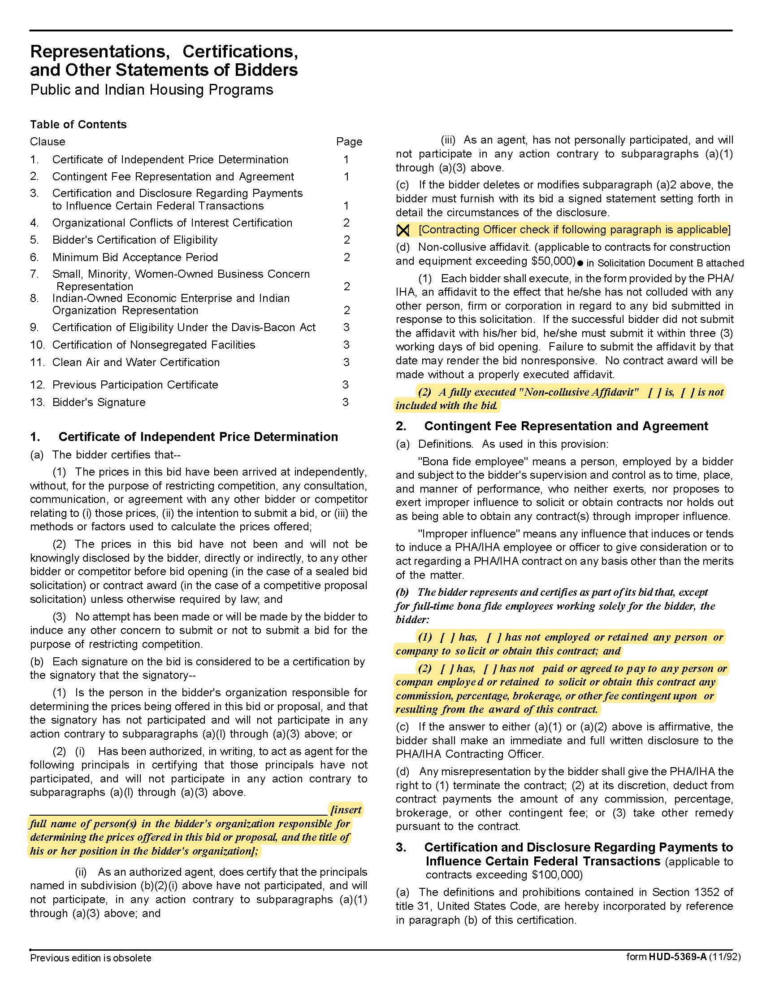

Project-Based Vouchers 060517 Q2010

Solicitation Document C HUD Form 5369A-continued
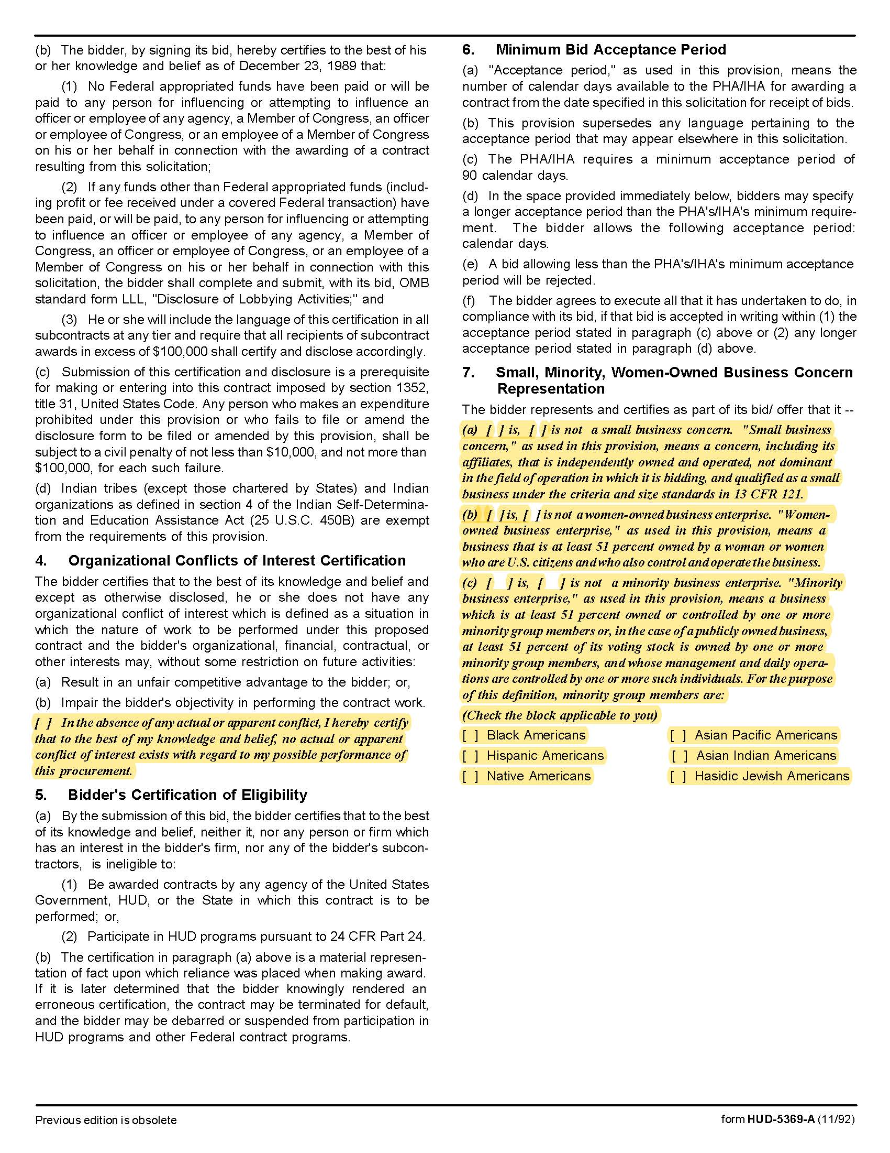

Project-Based Vouchers 060517 Q2010

Solicitation Document C HUD Form 5369A-continued
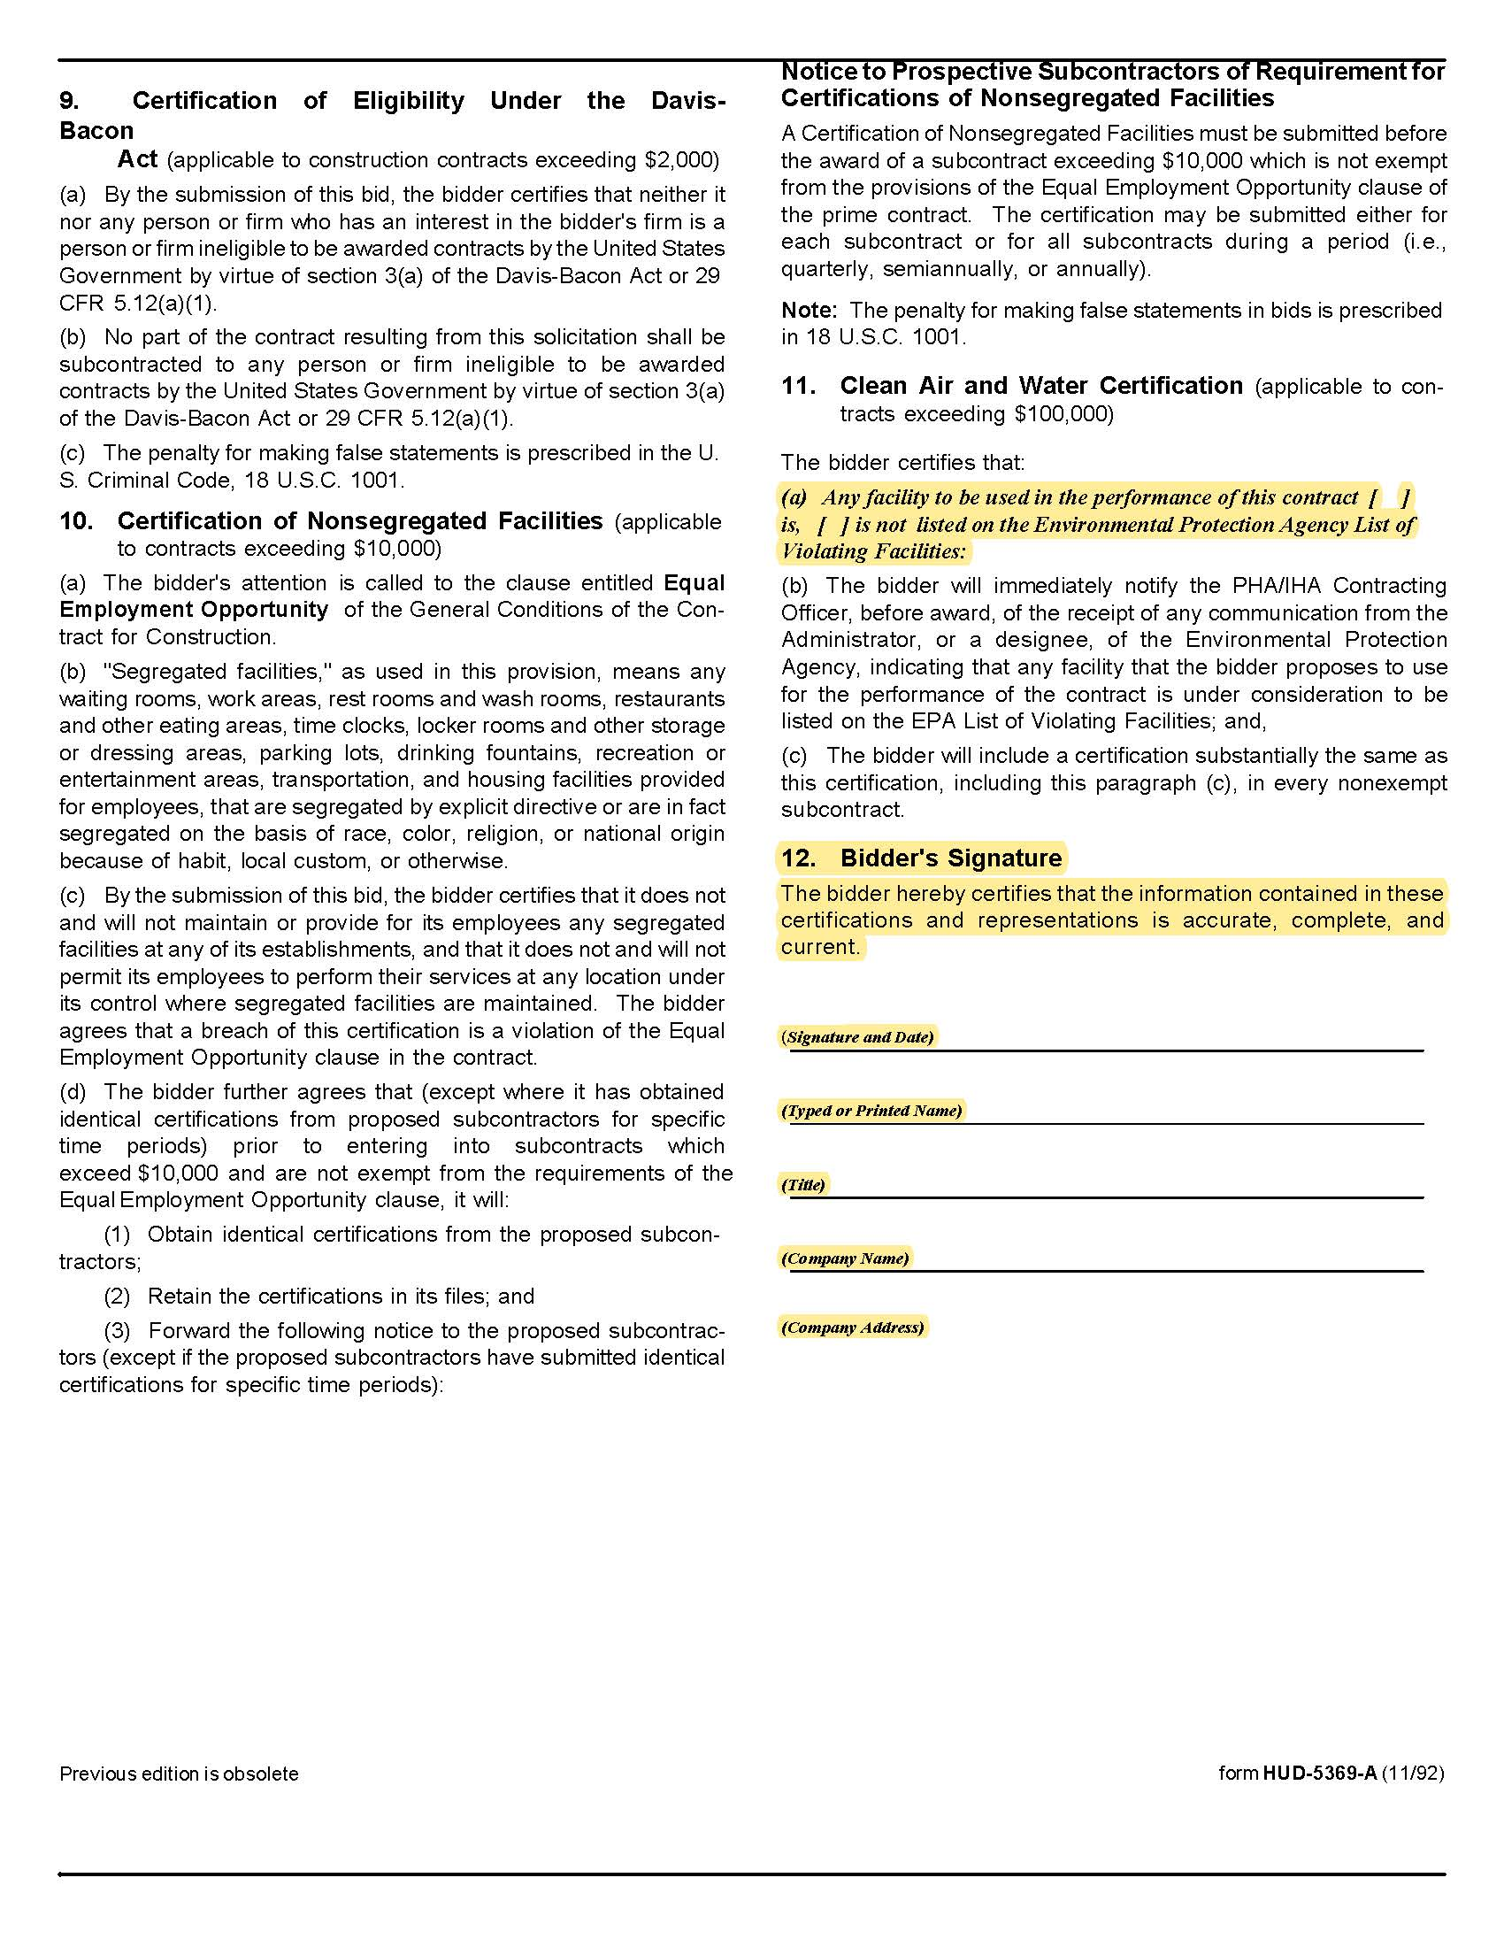

Project-Based Vouchers Q2010

Solicitation Document D Proposer’s Staff & Project Team Information

Using as many pages as needed, provide the following information for each employee whose project
responsibilities are considered to be significant for these projects.

1. Present two organizational charts:

a. The entire organization

b. One which identifies the key individuals and their proposed roles.

2. The names of the principal-in-charge and any other key lead personnel.

3. A paragraph summary of the person assigned as KCDC’s main contact. Include their background, education information and current position with the firm. There should be a particular focus on prior experience in affordable housing management and/or supportive services. Substitutions for key personnel listed to complete task must be with equally qualified persons. KCDC must be notified immediately of any substitutions.

4. A statement of the years of experience for each proposed employee:

a. Years with current firm (list titles and start dates)

b. Years in the industry (list titles, dates and companies)

5. A list of three major accounts/projects that the person has been involved in, using the following
format:

Employee Name
Name of Project Role the employee played Description of project
Name of Project Role the employee played Description of project
Name of Project Role the employee played Description of project

6. Any current certifications applicable to the professional services the employee will provide.

7. Other explanatory information.

Project-Based Vouchers Q2010

Solicitation Document E Proposer’s Housing Management Experience and Knowledge of State and

Federal Low Income Housing Programs

A. Provide the following information about the firm:

1. A narrative history including the date of inception or incorporation.

2. A narrative about the resources of the firm.

3. Names of Principal Owners (or indicate publically owned).

4. Number of years in business.

5. Location of the office to service KCDC.

6. Knowledge of State and/or Federal Low Income Housing Programs.

7. Evidence of the financial capacity to deliver the completed project in accordance with the commitments made in the proposal. Such evidence shall include audited financial statements of the proposer (or such other entities or individuals who will guarantee the proposer’s performance) for the most recent audited period.

8. Experience as an owner in the tenant-based voucher program and owner compliance with the owner’s obligations under the tenant-based program.

9. Owner experience and capability to build or rehabilitate housing.

10. References of three to five similar projects. Indicate:

- Customer Name
- Customer Address
- Nature of the Service Provided
- Contact Person
- Contact Person’s Email Address and Telephone Number

B. Provide information detailing your experience with housing management and supportive services. Include items such as:

1. Your experience in developing and administering the type of project being proposed, including constructing, marketing, renting and managing similar projects.

2. A detailed list of projects completed/managed in the last five years, indicating the start date, time required, completion date, key elements of the project, initial and final budgets.

Project-Based Vouchers Q2010

Solicitation Document E Proposer’s Housing Management Experience and Knowledge of State and

Federal Low Income Housing Programs-continued

3. A list of projects (regardless of type) funded through any other federal program (through either KCDC or another entity) within the past ten years, the funds award date and the status of each project.

4. Experience in providing permanent supportive housing with supportive services-if applicable.

5. Other explanatory information you wish to provide.

Project-Based Vouchers Q2010

Solicitation Document F Proposer’s PBV Plan

Use this section to fully explain your proposed project. Include the following items:

1. A narrative description of the proposed project including:

- Project type
- Project location(s): address(es) and map(s)
- Total number of units and number of units to be assisted with project-based voucher assistance
- Project amenities
- Energy efficient/green features

2. The persons who will benefit from the project, particularly special populations (i.e. elderly, disabled, families receiving supportive services, et cetera) -if applicable.

3. The need for the project and how you determined the need.

4. The geographic area from which you expect the project to draw the majority of its residents.

5. Demographic information such as, median household and family income; vacancy rates, populations trends, et cetera.

6. Information on other projects or available inventory that would compete with your project. Cite the sources of information used to provide the data.

7. The target market includes characteristics and income levels of households likely to be attracted to the development. Provide information on any waiting lists, as applicable.

8. Efforts (or plans) to gather community input for the project.

9. For new construction projects, address how the project meets the Site and Neighborhood requirements of 24 CFR 983.6(b).

10. How you will market your Project to potential tenants, particularly those least likely to apply.

11. The extent to which the project furthers the goals of de-concentrating poverty and expanding housing and economic opportunities.

12. The extent to which services for special populations are provided on site or in the immediate area for occupants of the property.

13. A narrative description of the existing housing units and the proposed supportive services.

Project-Based Vouchers Q2010

Solicitation Document F Proposer’s PBV Plan-continued

14. The extent to which units are occupied by families that are eligible to participate in the PBV program.

15. The project’s readiness. Provide a schedule for implementation, including a timeline for projected milestones, such as:

For Existing Housing

- Relocation Plan, if applicable
- Whether or not units meet HQS and are ready for occupancy. If not, describe the work needed and
the timeframe to bring them up to HQS or subsequent standards adopted by HUD.
- Anticipated lease-up date

For New Construction and Substantial Rehab Housing

- Environmental assessments
- Complete design
- Begin construction/rehab
- Complete construction/rehab
- Anticipated lease-up date

16. Potential impediments to the project’s readiness, such as zoning issues, relocation requirements, environmental concerns, infrastructure needs, et cetera.

17. Environmental review requirements (When developing the project schedule see Exhibit 1 and https://www.hudexchange.info/programs/environmental-review/ ).

18. Provide evidence of site control, such as a deed, option agreement, or sales contract.

19. Evidence of funds adequate to meet construction expenses. The proposer must have firm financial commitments for all funding sources before KCDC will enter into an agreement. Attach documentation of all funds listed as committed in the Project-Based Voucher Application.

20. A 20-year operating pro forma for the proposed project.

21. A detailed contractor’s cost estimate for the type of needed work. Proposers should consider the Davis-Bacon wage rates when preparing the cost estimate if the project will consist of 9 or more contract units.

Project-Based Vouchers Q2010

Appendix 1 Environmental Review Requirements

An environmental review is the process of reviewing a project and its potential environmental impacts to determine whether it meets federal, state and local environmental standards. The environmental review process is triggered when HUD, a HUD program participant, or a HUD grantee purchases, or intends to purchase, property with HUD funds. All properties to be developed with HUD assistance (including HOME funds) must have an environmental review to ensure that the proposed project does not negatively impact the surrounding environment and that the property site itself is safe for development. Not every project is subject to a full environmental review (i.e., every project's environmental impact must be examined, but the extent of this examination varies), but every project must be in compliance with the National Environmental Protection Act (NEPA) and other related Federal and state environmental laws.

A responsible entity will commence the environmental review process upon execution of a Conditional Commitment Agreement with the Owner/Developer. Until the completion of the environmental review process additional funds (federal, private, or other) cannot be committed or expended and no work (including property acquisition) can be undertaken on the project until the responsible entity completes the environmental review and has received a Release of Federal Funds (ROFF) from HUD. Where a project is in progress (regardless of the source of funds), actions must cease until the environmental review process is completed.

The extent of the environmental review and time required to complete depends upon the activity and its scope. If a Project includes multiple activities, such as acquisition and new construction of 5 or more units, the highest level of environmental review required will be performed. KCDC will not consider proposed projects in a floodplain. The table on the following page summarizes the level of environmental review required for the eligible activities that may be undertaken through this Application and estimated timeframes for completion.

Project-Based Vouchers Q2010

Appendix 1 Environmental Review Requirements-continued

Estimated Environmental Review Timeframes

Eligible Activity | Environmental Review Level | Estimated Timeframes
Relocation | Highest level required for the project | Highest level required  for the Project
Rehabilitation of Multi-family Housing  - Unit density not changed more than 20%  - Project does not involve changes in land use from residential to non-residential; and  - Estimated cost of rehab is less than 75% of the total estimated cost of replacement after rehab | Categorical exclusion  subject to 24 CFR §58.5 | 90 days
“Individual Action”  - Acquisition; new construction or individual action on a project of 5 or more units developed on scattered sites when sites are more than 2000 feet apart and there are not more than 4 units on any site | Categorical exclusion  subject to 24 CFR § 58.5 | 90 days
Acquisition | Highest level required for the Project | Highest level required for the Project
New Construction – Multifamily  - 5 or more units | Environmental Assessment | 120 days

Project-Based Vouchers Q2010

Appendix 2 Site and Neighborhood Standards

See attached HUD regulations for Existing and Rehabilitated Housing Site and Neighborhood Standards 24 CFR 983.57(d) and New Construction Site and Neighborhood Standards 24CFR983.57(e).

The Site Selection Plan must be provided with this RFP.

The proposer is responsible for all review costs.

Project-Based Vouchers Q2010

Appendix 3 Subsidy Layering Review Requirements

When KCDC selects a new construction or rehabilitation project, pursuant to program regulations at 24 CFR Part 983 and the project combines other forms of governmental assistance, KCDC must request a subsidy layering review by HUD and the review must be completed before entering into an Agreement to Enter a Housing Assistance Payments (AHAP) Contract.

As part of the selection process, KCDC must receive information regarding all HUD and/or other federal, State, or local governmental assistance to be disclosed by the project owner. Form HUD 2880
(http://portal.hud.gov/hudportal/documents/huddoc?id=2880.pdf ) may be used for this purpose.

Owners/Developers must complete and submit a disclosure statement even if no other governmental assistance has been received or is anticipated. The statement must be submitted with the owner’s application for project-based vouchers. If any information changes on the disclosure, either by the addition or deletion of other governmental assistance, the project owner must submit a revised disclosure statement. If before or during the HAP contract, the owner receives additional HUD or other governmental assistance for the project that results in an increase in project financing in an amount that is equal to or greater than 10 percent of the original development budget, the owner must report such changes to KCDC so KCDC may inform HUD that a further subsidy layering review is required.

Project-Based Vouchers Q2010

Appendix 4 Section 504 Requirements

Determining the Number of Units That Must Be Made Accessible

The table below summarizes the accessibility requirements of Section 504 of the Rehabilitation Act of 1973 and the implementing regulations of 24 CFR Part 8. Frequently asked questions regarding section 504 requirements are available on line at: http://portal.hud.gov/hudportal/HUD?src=/program_offices/fair_housing_equal_opp/disabilities/sect504faq

Additional resources pertaining to housing for persons with disabilities is available at:
http://portal.hud.gov/hudportal/HUD?src=/program_offices/fair_housing_equal_opp/disabilities .

Project Type | Accessibility Requirement
New construction of multifamily rental housing | - For projects with five (5) or more units: A minimum of 5% of the total number of dwelling units in a project (but not less than one unit) must be accessible to individuals with mobility impairments in accordance with the Uniform Federal Accessibility Standards (UFAS). An additional 2% of the dwelling units (but not less than one unit) must be accessible to individuals with hearing or vision impairments. This is based on the total number of units in the project, not just the assisted units.
Rental housing with substantial alterations | - For projects with 15 or more units and the cost of the alterations is 75% or more of the replacement cost of the completed development: A minimum of 5% of the total number of dwelling units in a project (but not less than one unit) must be accessible to individuals with mobility impairments in accordance with the UFAS. An additional 2% of the dwelling units (but not less than one unit) must be accessible to individuals with hearing or vision impairments. This is based on the total number of units in the project, not just the assisted units.
Rental housing with other alterations | - For multi-family projects in which the cost of alterations is less than 75% of the replacement cost of the completed development: Alterations to the dwelling units shall be made readily accessible to and usable by individuals with disabilities, to the maximum extent feasible. All alterations must meet the applicable sections of the UFAS that govern alterations. Alterations that require removing of altering load-bearing structural member are not required. If alterations to single elements or spaces of a dwelling unit, when considered together, amount to an alteration of a dwelling unit, then the entire unit must be made accessible.

