## Invitation for Sealed Bids



Appliances (as needed)

|  |  |
| --- | --- |
| **Solicitation Number** | Q1804 |
| **Due Date** | July 21, 2017 |
| **Due Time** | 11:00 a.m. eastern standard time |
| **Deliver Responses to:** | Knoxville’s Community Development Corporation  OA4_logo_webProcurement Division  901 N. Broadway  Knoxville, TN 37917 |
| **Electronic Copies:** | Proposers are encouraged to use the Adobe fillable or MS Word version to provide a typed.  Electronic copies are available on TAHRA’s webpage or by emailing [purchasinginfo@kcdc.org](mailto:purchasinginfo@kcdc.org)**.** |
| **May responses be emailed to TAHRA** | Yes  No  However, if the solicitation calls for written submittals, they must be provided as indicated. |
| **Solicitation Meeting** | Yes  No |
| **Solicitation Meeting is Mandatory** | Yes  No |
| **Solicitation Meeting Date** | Not Applicable |
| **Solicitation Meeting Time** | Not Applicable |
| **Solicitation Meeting Location** | Not Applicable |
| **Questions About This Solicitation** | Submit questions to [purchasinginfo@kcdc.org](mailto:purchasinginfo@kcdc.org) |

## Check TAHRA’s webpage for addenda and changes before submitting your response

## General Information

1. **BACKGROUND AND INTENT**

a. Knoxville's Community Development Corporation (KCDC) is the public housing and redevelopment agency for the City of Knoxville and for the County of Knox in Tennessee. KCDC’s public housing property portfolio includes 20 sites with approximately 3,547 dwelling units. KCDC also administers approximately 3,958 vouchers and 82 moderate rehabilitation units through our Section 8 department.

b. TAHRA issued this solicitation on behalf of the Tennessee Association Housing & Redevelopment Authorities (TAHRA). Hereafter the terms “KCDC” and “TAHRA” are used interchangeably.

c. The various Public Housing Authorities (PHAs) in the State of Tennessee often purchase common items while furnishing their units. Common items include household type appliances. Realizing that there are often discounts for quantity purchases, TAHRA agreed to coordinate one solicitation that any or all housing agencies (plus any other governmental entity that so desires) may use.

d. Once the award is made, the successful supplier will honor orders, at the specified prices, from any TAHRA member agency, city, county or state agency or any other municipality or political subdivision choosing to participate.

e. However, no agency or governmental entity is required to participate and may conduct separate procurements for items contained in this solicitation. Additionally, TAHRA does not guarantee any orders will be placed and assures no responsibility, financial or otherwise, for purchases made under this contract.

f. This solicitation is to provide modern, efficient and Energy Star rated (as applicable) dishwashers, ranges and refrigerators for use by Public Housing Authorities across the State of Tennessee.

g. Upon award, the successful suppliers will need to market the program to the TAHRA membership. For such purposes, TAHRA will work with the suppliers to communicate award notice and materials.

h. The successful suppliers are strongly encouraged to consider active participation in TAHRA, including attendance at its spring and fall meetings. Additionally, the supplier may want to consider becoming an affiliate member of TAHRA. Details are on TAHRA’s webpage at <http://tahranet.org/>**.**

2. **CHANGES AFTER AWARD**

It is possible that after award the TAHRA may need to revise the service needs or requirements specified in this document. TAHRA reserves the right to make such changes after consultation with the supplier(s). Should additional costs arise, TAHRA reserves the right to consider accepting these charges provided the supplier(s) can document the increased costs. TAHRA reserves the right to make such changes after consultation with the supplier(s).

TAHRA also reserves the right to accept proposed service changes from the supplier if they will lower the cost to TAHRA and/or provide improved service.

3. **EVALUATION**

TAHRA will arrive at the “lowest and best” solution for the final award and this may not entail simply awarding to the supplier quoting the lowest cost. All responses are subject to a determination of “responsive” and “responsible” prior to award. TAHRA is the sole judge as to supplier “responsiveness” and “responsibility.” TAHRA reserves the right to request additional information to assist in the evaluation process.

4. **GENERAL INSTRUCTIONS**

TAHRA does not insert “General Instructions to Vendors” in the solicitation document. These instructions are at [www.kcdc.org](http://www.kcdc.org). Click on “Procurement” and follow the link. By submitting a response to this solicitation, the supplier accepts the responsibility for downloading, reading and abiding by the terms and conditions set forth in KCDC’s “General Instructions to Vendors.” Suppliers may wish to review certain applicable HUD instructions also on KCDC’s webpage.

5. **INVOICING/ORDERING**

This section is germane to KCDC only.

a. Until a purchase order is in place, work is not to be performed nor are goods to be delivered. As purchase orders authorize work and obligate payment, if suppliers work without a purchase order in place, KCDC does not have a legal obligation to pay for the work.

b. Invoices must:

1. Be numbered.

2. Have a date on them that is after the work is completed or goods delivered.

3. Show the purchase order number.

4. Breakdown pricing according to the bid structure

5. Be suitable for scanning since KCDC does not maintain paper records.

c. Suppliers are required to submit invoices within 90 days after the delivery of the goods or services. KCDC may deny invoices submitted after the 90 day threshold.

d. KCDC’s purchases of goods are exempt from Tennessee sales and use tax pursuant to Tennessee Code Annotated 67-6-329(a) (4) and KCDC is generally exempt from the Federal Excise tax. Contractors are subject to Tennessee sales and use tax on all materials and supplies used in the performance of a contract, whether such materials and supplies are purchase by the contractor, produced by the contractor, or provided to the contractor by KCDC, pursuant to Tennessee Code Annotated 67-6-209. The contractor will pay all taxes incurred in the performance of an awarded contract.

Upon the placement of a purchase order or the award of a contract, KCDC will provide a State of Tennessee Sales Tax Exemption form to the supplier. KCDC will not pay taxes on invoices.

e. KCDC pays by electronic transfer (ACH) only.

6. **LENGTH OF AWARD**

The initial award is for 12 months. The award has four one-year optional renewals that TAHRA may choose to exercise.

7. **PRICE STRUCTURE**

a. At the end of each award year, the successful supplier may request a price increase. Proof of increased cost to the successful supplier must accompany price increase requests. TAHRA may, at its option:

1. Accept the proposed price increase.

2. Reject the proposed price increase.

3. Suggest an alternative price increase.

b. If TAHRA rejects a proposed price, the successful supplier may:

1. Continue with the existing pricing.

2. Suggest an alternative price increase.

3. End the award.

c. While the supplier may offer other goods, only those specifically awarded are “on contract.” Other goods offered are not covered by the award and can only be procured through specific purchase orders identifying the special goods to be offered and the price for them. TAHRA’s and the normal procurement thresholds of other entities will apply.

d. If one supplier elects to not renew or TAHRA elects to not renew with a supplier, the remaining suppliers may continue with the entire award or the solicitation may be re-issued.

e. If Energy Star requirements change during this award or contract, TAHRA reserves the right to renegotiate the award or contract with the successful supplier(s) to meet the new standards without going out for new bids, if so desired.

8. **QUANTITIES**

While this is an “As Needed” solicitation and no specific quantities are guaranteed and while this solicitation is intended for all members of TAHRA (see Appendix I for a listing), the following quantities are known to have purchased in 2016 by TAHRA, Metropolitan Development and Housing Authority (MDHA) and the Chattanooga Housing Authority (CHA).

|  |  |
| --- | --- |
| **Item** | **Total Units Purchased** |
| Ranges | 158 |
| Refrigerators | 251 |
| Dishwashers | 38 |

9. **QUESTIONS**

Direct questions to [purchasinginfo@TAHRA.org](mailto:purchasinginfo@KCDC.org) with “Appliances” in the subject line, at least five days prior to the due date**.**

10. **USE OF SOLICITATION FORMS**

Suppliers are to complete the solicitation forms contained in the solicitation package. Failure to complete these forms may result in rejection of your response. Do not alter the solicitation forms without TAHRA’s approval. Vendors are asked to use the Adobe fillable version of the pricing pages to eliminate difficulties in reading handwritten text.

## Specifications

11. **GENERAL REQUIREMENTS**

The supplier shall furnish all equipment and material, and it shall be commercial quality from a regular product line. This request for bid is not intentionally written around any one manufacturer and is to indicate the general size, type and description of equipment needed.

12. **ENERGY STAR**

TAHRA is very interested in energy efficiency. Energy Star certified appliances ***are required*** unless there are no such models currently so certified.

13. **DELIVERY**

a. Delivery shall be F.O.B. Destination, freight paid by the supplier, to the ordering entity. Delivery charges are included in the per unit cost. The driver will, at the minimum, assist PHA staff with unloading appliances to the tailgate of the delivery truck.

b. Agencies shall have the right to mix sizes and types of products to obtain quantity pricing. Prices given are for delivery F.O.B. to any point within Tennessee for purchases made by any participating entity. Should a governmental entity outside of Tennessee desire to use this award/contract, the supplier and the entity will negotiate shipping charges.

c. KCDC’s delivery needs have changed and now deliveries are directly to KCDC sites. While some sites can easily accommodate large trucks, many cannot accept trucks longer than fourteen (14) feet. Most KCDC sites do not have docks and so the supplier will have to arrange lift gate delivery.

14. **MODEL AND PRICE CHANGE NOTIFICATION**

After award, if models change and/or prices increase (see above concerning price increases), the supplier(s) must notify TAHRA. Upon approval, notification will be sent to other TAHRA members.

15. **PACKING AND MARKING**

Packaging, packing and marking shall be in accordance with standard commercial practices and be specified in the contract or order. TAHRA encourages environmentally friendly packaging and the general reduction of packaging materials.

16. **DISHWASHERS** - Note that the item descriptions in this section follow on the pricing page.

TAHRA wants four types of dishwashers available for its members.

a. Dishwasher - Basic

These will:

* Be available in white or almond
* Be equal to the Energy Star qualified Whirlpool Model WDF330PAHW
* Be equipped with a pots and pans cycle
* Be equipped with three automatic cycles
* Have an air dry option
* Have a one piece injection molded tub
* Have in-rack silverware basket

b. Dishwasher - Upgrade 1

These will:

* Be available in black
* Be able to hold up to thirteen place settings
* Be able to adjust the rack height to accommodate taller items.
* Have a heavy wash cycle
* Equal to the Energy Star qualified Whirlpool Model WDF320PADB Tall Tub Built-in Dishwashers

c. Dishwasher - Upgrade 2

These will:

* Be available in black
* Be equal to the Energy Star qualified Whirlpool Model WDF520PADB Built In Dishwashers

d. Dishwasher 1 – Handicap ADA Compliant

Equal to Whirlpool Model WDF550SAFW

17. **ELECTRIC RANGES** - Note that the item descriptions in this section follow on the pricing page.

a. General Comments:

TAHRA wants five types of electric ranges available for its members.

Standard Ranges

1. Type 1, Style 1, Size 1 (20/21”): Range with four surface cooking units (three 6-inch and one 8-inch) with oven and broiler below.

2. Type 1, Style 1, Size 2 (24”): Range with four surface cooking units (three 6-inch and one 8-inch) with oven and broiler below.

3. Type 1, Style 1, Size 3 (30”): Range with four surface cooking units (three 6-inch and one 8-inch) with oven and broiler below.

4. Type 1, Style 1, Size 4 (36”): Range with four surface cooking units (three 6-inch and one 8-inch) with oven and broiler below.

Operating Service is either 115/120 volts or 120/208 volts, 3-wire or 4-wire, single-phase, 60HZ.

The standard electric range connection cords will not be ordered with the ranges. Therefore, the cost of connection cords is not to be included in the price of the range.

Ranges, at a minimum, shall have one indicator light that will indicate when any of the top burners are on and one oven indicator light to show when the oven is heating.

An oven time control is not required.

Each range shall be equipped with at least four leg levelers and anti-tilt brackets or approved anti-tilt devices.

All ranges are to be equipped with two oven racks.

The range cook top, oven box, door, control panel, and door exterior shall be porcelain enamel. Range side panels, oven and storage drawers, if equipped, shall be porcelain or a suitable high-temperature baked enamel.

Ranges shall have solid doors.

Ranges shall have a UL listing and the supplier shall provide a copy of the UL labels in the brochures.

b. Standard Electric Range - Type 1/Style 1

* Equal to Brown Stove Works Model WEM112-Y 20”
* Equal to Brown Stove Works Model WEM612-Y 24”
* Equal to Brown Stove Works Model WEM210 30”
* Equal to Brown Stove Works Model WEM430-KW 36”

c. Electric Range Upgrade 1

* 30”
* Black
* Self-cleaning oven
* Extra Large Oven Capacity
* Equal to Kenmore 93019

d. Electric Range - Elderly/Handicap 1 – 20/21 Inch

Ranges for elderly/handicap housing shall have:

* The features stated in Section 17.a.
* Individual oven and surface indicator lights
* Oven light bulb with door operated on/off surface or on/off switch on front panel
* Equal to Brown Stove Works WEM118-Q

e. Electric Range - Elderly/Handicap 2 – 24 Inch

Equal to Brown Stove Works WNM610-7Y

f. Electric Range - Elderly/Handicap 3 – 30 Inch

Equal to Brown Stove Works WNM210-7Y

18. **GAS RANGES** - Note that the item descriptions in this section follow on the pricing page.

a. Ranges, or parts thereof, supplied under this specification shall fulfill the construction and performance requirements of the latest edition of the American National Standard Institute (ANSI) Z21.1 and Z21.20 (when applicable).

The cooking top shall be provided with four burners. Each burner shall be rated at no less than 9000 BTU.

Each top burner shall be provided with a porcelain-enameled cast iron or steel grate.

All burners shall be equipped with automatic ignition of the gas. Failure of the over-burner pilot shall activate a means for shutting off gas to the over-burner. This shall meet the applicable requirements of the ANSI Z21.20-2014. The electric ignition system may be spark, coil, glow bar or a combination of these.

An oven thermostat control shall be provided for controlling oven temperatures down to 170˚F. The baking oven and broiling section shall be porcelain enamel coated steel. The broiling section shall be either of the drop door type, pull out type or swing door type. Stops shall be provided so that oven racks cannot be completely pulled out by accident.

Ovens shall be provided with a vent designed to deflect moisture and fumes away from the wall behind the range.

At a minimum, the back guard, main top, control panel and door shall be porcelain enamel. All other exterior surfaces shall be finished in synthetic, baked-on enamel capable of withstanding 250˚F. The range body, back panel, legs and/or base shall be porcelain enamel, baked-on enamel, galvanized or aluminized steel. The area under the main top may be porcelain enamel or synthetic, baked-on enamel.

Each range shall be equipped with a back splash not less than four inches higher than the top cooking surface and extending the full width of the range top.

The equipment and accessories supplied with each range, such as oven and broiler racks, shall be those normally supplied with the manufacturer’s standard production for the type range ordered.

All gas ranges are to have four adjustable legs for leveling and are to be equipped with anti‑tipping brackets.

The top of the range is to be lifting top for ease of cleaning under and around the top burners with a support bracket to hold the top in an elevated position, or have a lift-off top.

b. Standard Gas Range 20”/21”

Equal to Brown Stove Works WNM110-7Y

c. Gas Range 30” - With 9 volt battery ignition system

* White
* Equal to Brown Stove Works WNM210-PY

19. **MICROWAVES** - Note that the item descriptions in this section follow on the pricing page.

TAHRA wants five microwaves available for purchase. These are:

a. Microwave 1 - Counter Top

* 0.7 cubic feet capacity
* 700 watts
* Defrost function
* Convenience cooking controls
* Turntable
* Kitchen Timer
* Control Lock
* Equal to Whirlpool WMC10007AW

b. Microwave 2 - Counter Top

* .7 cubic feet capacity
* 700 watts
* Defrost function
* Convenience cooking controls
* Turntable
* Control lockout
* Equal to Whirlpool WMC10007AB

c. Microwave 3 - Spacemaker Over the Range

* 1.6 cubic foot capacity
* 950 watts
* Defrost function
* Convenience cooking controls
* Turntable on/off function
* Two speed venting system
* Ten power levels
* Equal to GE Model JVM3160DFBB

d. Microwave 4 - Spacemaker Over the Range

* 1.7 cubic foot capacity
* 1000 watts
* Defrost function
* Convenience cooking controls
* Removable Oven Rack
* Turntable on/off function
* Two speed venting system
* Ten power levels
* Equal to Whirlpool WMH31017AW

e. Microwave 5 – Spacemaker Over the Range

* Black
* 2.0 cubic foot capacity
* 1000 watts
* Defrost function
* Four speed exhaust fan
* 10 power levels
* Equal to Amana AMV6502REW

20. **RANGE HOODS** - Note that the item descriptions in this section follow on the pricing page.

TAHRA wants two range hoods available for purchase.

a. Range Hood 1

* Vented
* Vertical and Rear Exhaust
* Variable two-speed fan control
* Cooktop light
* Removable grease filter
* Equal to GE Model JV338H

b. Range Hood 2

* Non-vented
* Variable two-speed fan control
* Cooktop light
* Removable grease filter
* Equal to GE Model JN327H

21. **REFRIGERATORS** - Note that the item descriptions in this section follow on the pricing page.

Refrigerator sizes are general size requirements. Suppliers may bid nearest to the size listed (i.e. 13.9-15.5 cubic feet refrigerators are considered 14 cubic feet models, and 15.6-16.5 cubic feet refrigerators are considered 16 cubic feet models).

Refrigerators shall be the self-contained and self-defrosting, household type with electric motor driven condensing units. All refrigerators shall be furnished with shelves in the door and vegetable drawers or crisper trays.

The exterior doors shall have reversible hinges which allow for left or right swing and be equipped with a magnetic gasket.

The interior liners of food storage compartments shall be porcelain enamel on steel or plastic.

The temperature control shall be equipped with an off position and contact points or setting positions for a wide range of degree of temperature.

Each refrigerator shall be furnished with a minimum of two standard size ice cube trays.

Each refrigerator shall include one or more vegetable drawers or crisper trays which are readily removable. These shall be constructed of steel finished with porcelain enamel, anodized aluminum or durable plastic, durable glass or non-corrosive metal.

Refrigerators are to be equipped with four rollers (for ease of moving the refrigerator without damage to the floor covering.) The two backside rollers may be stationary with the two front side rollers adjustable up and down for leveling the refrigerator.

Refrigerators must meet the September 2014, United States Department of Energy Freezer/Refrigerator Energy Star standards.

1. Refrigerators - Basic 1:

* Recessed handle
* 14.6 cu. feet
* Energy Star Compliant
* Equal to Hotpoint HPE15BTHWW

1. Refrigerator - Upgrade 1

* Black
* Pull handle
* 16.6 cu. feet
* Equal to GE Model GTE16DTHWW

1. Refrigerator - Elderly/Handicapped 1

* ADA Compliant
* 18.2 cu. feet
* Equal to GE Energy Star Model GTE18ETHWW
* Pull handle

1. Refrigerator - Elderly/Handicapped 2

* ADA Compliant
* 23.2 cu. feet
* Equal to GE Energy Star Model GSS23GSKSS
* Side by side

**This and the previous pages do not need to be returned**

## Appliances (as needed) Q1804

## Solicitation Document A General Response Section

|  |  |  |  |  |  |  |  |  |  |  |  |  |  |
| --- | --- | --- | --- | --- | --- | --- | --- | --- | --- | --- | --- | --- | --- |
| **General Information about the Supplier** | | | | | | | | | | | | | |
| **Sign Your Name to the Right of the Arrow**  Your signature indicates that you have read and agree to “TAHRA’s General Instructions to Vendors” on [www.kcdc.org](http://www.kcdc.org). | | | | | | | |  | | | | | |
| **Printed Name and Title** | | | | | | | |  | | | | | |
| **Company Name** | | | | | | | |  | | | | | |
| **Street Address** | | | | | | | |  | | | | | |
| **City/State/Zip** | | | | | | | |  | | | | | |
| **Contact Person (Please Print Clearly)** | | | | | | | |  | | | | | |
| **Telephone Number** | | | | | | | |  | | | | | |
| **Cell Number** | | | | | | | |  | | | | | |
| **Supplier’s e-mail address (Please Print Clearly)** | | | | | | | |  | | | | | |
| **Addenda** | | | | | | | | | | | | | |
| **Addenda are at** [www.kcdc.org](http://www.kcdc.org)**. Click on “Procurement” and then on “Open Solicitations” to find addenda. Please check for addenda prior to submitting a bid.** | | | | | | | | | | | | | |
| **Acknowledge addenda have been issued by checking below as appropriate:** | | | | | | | | | | | | | |
| **None** | **Addendum 1** | | | **Addendum 2** | | | **Addendum 3** | | | **Addendum 4** | | | **Addendum 5** |
| **Statistical Information** | | | | | | | | | | | | | |
| **This business is owned & operated by persons at least 51% of the following ethnic background:** | | | | | | | | | | | | | |
| **Asian/Pacific** | | **Black** | **Hasidic Jew** | | | **Hispanic** | | | **Native**  **Americans** | | | **White** | |
| **As defined on TAHRA’s webpage (see the “General Instructions to Vendors”), this business qualifies as:** | | | | | | | | | | | | | |
| **Section 3** | | | | | **Small Business** | | | | | | **Woman Owned** | | |
| **Prompt Payment Discount** | | | | | | | | | | | | | |
| **A prompt payment discount of \_\_\_\_\_\_\_\_% is offered for payment within \_\_\_\_ days of submission of an**  **accurate and proper invoice.** | | | | | | | | | | | | | |

## Appliances (as needed) Q1804

## Solicitation Document B Affidavits

Supplier: \_\_\_\_\_\_\_\_\_\_\_\_\_\_\_\_\_\_\_\_\_\_\_\_\_\_\_\_\_\_\_\_\_\_\_\_\_\_\_\_\_\_\_\_\_\_\_\_\_\_\_\_\_\_\_\_\_\_\_\_\_\_\_\_\_\_\_\_\_\_\_\_\_\_\_\_\_

**Conflict of Interest**

1. No commissioner or officer of TAHRA or other person whose duty it is to vote for, let out, overlook or in any manner superintend any of the work for TAHRA has a direct interest in the award or the supplier providing goods or services.

2. No employee, officer or agent of the grantee or sub-grantee will participate in selection, or in the award or administration of an award supported by Federal funds if a conflict of interest, real or apparent, would be involved. Such a conflict would arise when the employee, officer or agent, any member of his immediate family, his or her partner, or an organization, which employs, or is about to employ, any of the above, has a financial or other interest in the supplier selected for award.

3. The grantee's or sub-grantee's officers, employees or agents will neither solicit nor accept gratuities, favors or anything of monetary value from suppliers, potential suppliers, or parties to sub-agreements.

4. By submission of this form, the supplier is certifying that no conflicts of interest exist.

**Drug Free Workplace Requirements**

5. Private employers with five or more employees desiring to contract for construction services attest that they have a drug free workplace program in effect in accordance with TCA 50-9-112.

**Eligibility**

6. The supplier is eligible for employment on public contracts because no convictions or guilty pleas or pleas of nolo contender to violations of the Sherman Anti-Trust Act, mail fraud or state criminal violations with an award from the State of Tennessee or any political subdivision thereof have occurred.

**General**

7. Supplier fully understands the preparation and contents of the attached offer and of all pertinent circumstances respecting such offer.

8. Such offer is genuine and is not a sham offer.

## Appliances (as needed) Q1804

## Solicitation Document B Affidavits-continued

9. **Iran Divestment Act**

Concerning the Iran Divestment Act (TCA 12-12-101 et seq.), by submission of this bid/proposal/quote, each supplier and each person signing on behalf of any supplier certifies, and in the case of a joint bid/proposal/quote, each party thereto certifies as to its own organization, under penalty of perjury, that to the best of its knowledge and belief that each supplier is not on the list created pursuant to § 12-12-106.

10. **Non-Collusion**

Neither the said supplier nor any of its officers, partners, owners, agents, representatives, employees or parties interest, including this affiant, has in any way colluded, conspired, connived or agreed, directly or indirectly, with any other responder, supplier, or person to submit a collusive or sham offer in connection with the award or agreement for which the attached offer has been submitted or to refrain from making an offer in connection with such award or agreement, or collusion or communication or conference with any other supplier, or, to fix any overhead, profit, or cost element of the offer price or the offer price of any other supplier, or to secure through any collusion, conspiracy, connivance, or unlawful agreement any advantage against TAHRA or any person interested in the proposed award or agreement.

11. The price or prices quoted in the attached offer are fair, proper and not tainted by any collusion, conspiracy, connivance, or unlawful agreement on the part of the supplier or any of its agents, representatives, owners, employees, or parties in interest, including this affiant.

The undersigned hereby acknowledges receipt of this Solicitation Document B and certifies that the submittal in response to this solicitation is in full compliance with the listed requirements.

|  |  |
| --- | --- |
| **Signed by** |  |
| **Printed Name** |  |
| **Title** |  |
| **Subscribed and sworn to before me this date** |  |
| **By (Notary Public)** |  |
| **My Commission Expires on** |  |
| **Notary Stamp** | |

## Appliances (as needed) Q1804

## Solicitation Document C HUD Form 5369A

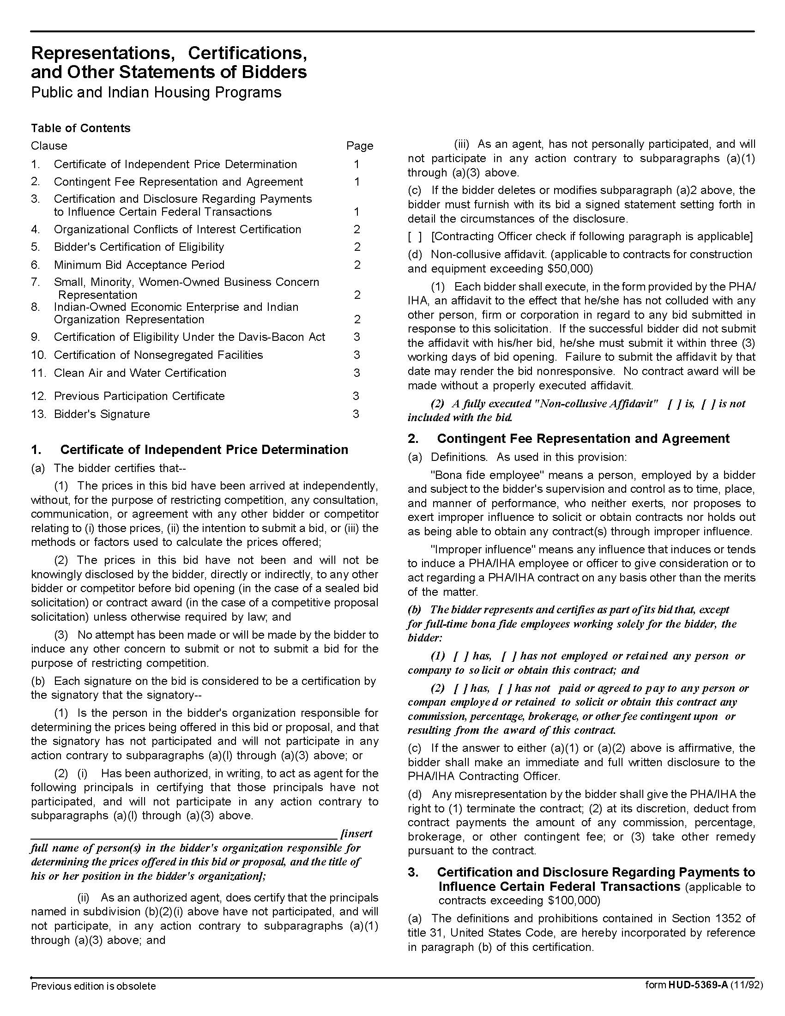

## Appliances (as needed) Q1804

## Solicitation Document C HUD Form 5369A-continued

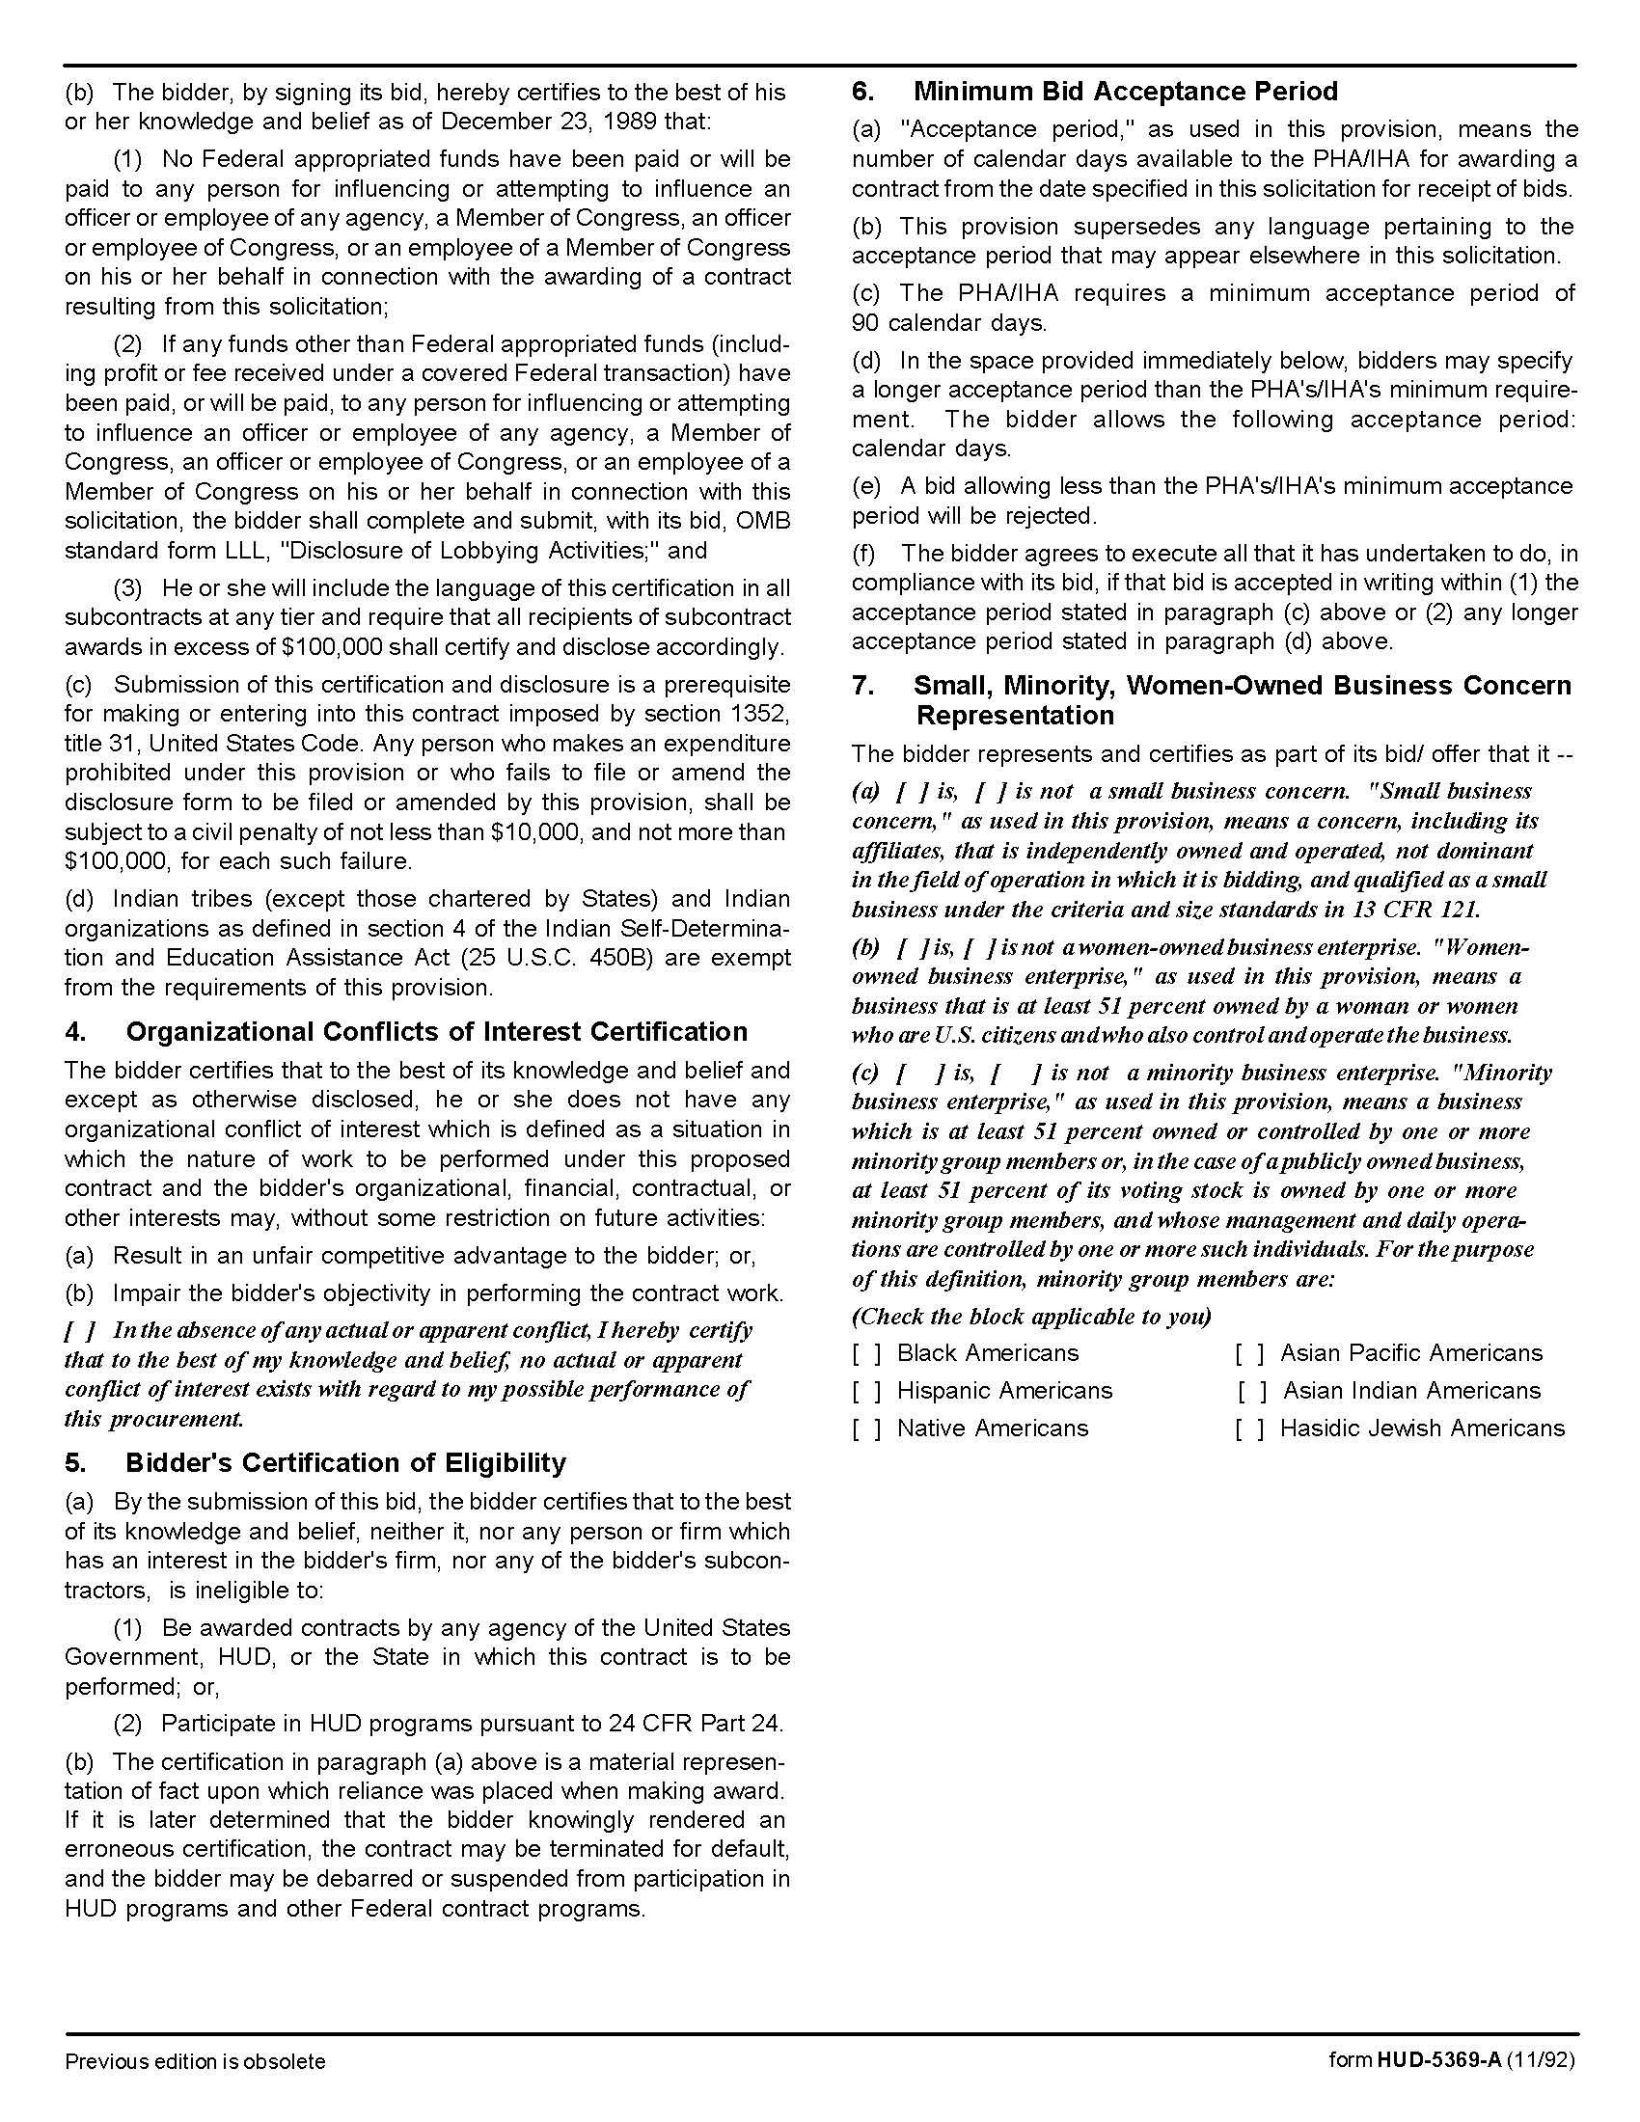

## Appliances (as needed) Q1804

## Solicitation Document C HUD Form 5369A-continued

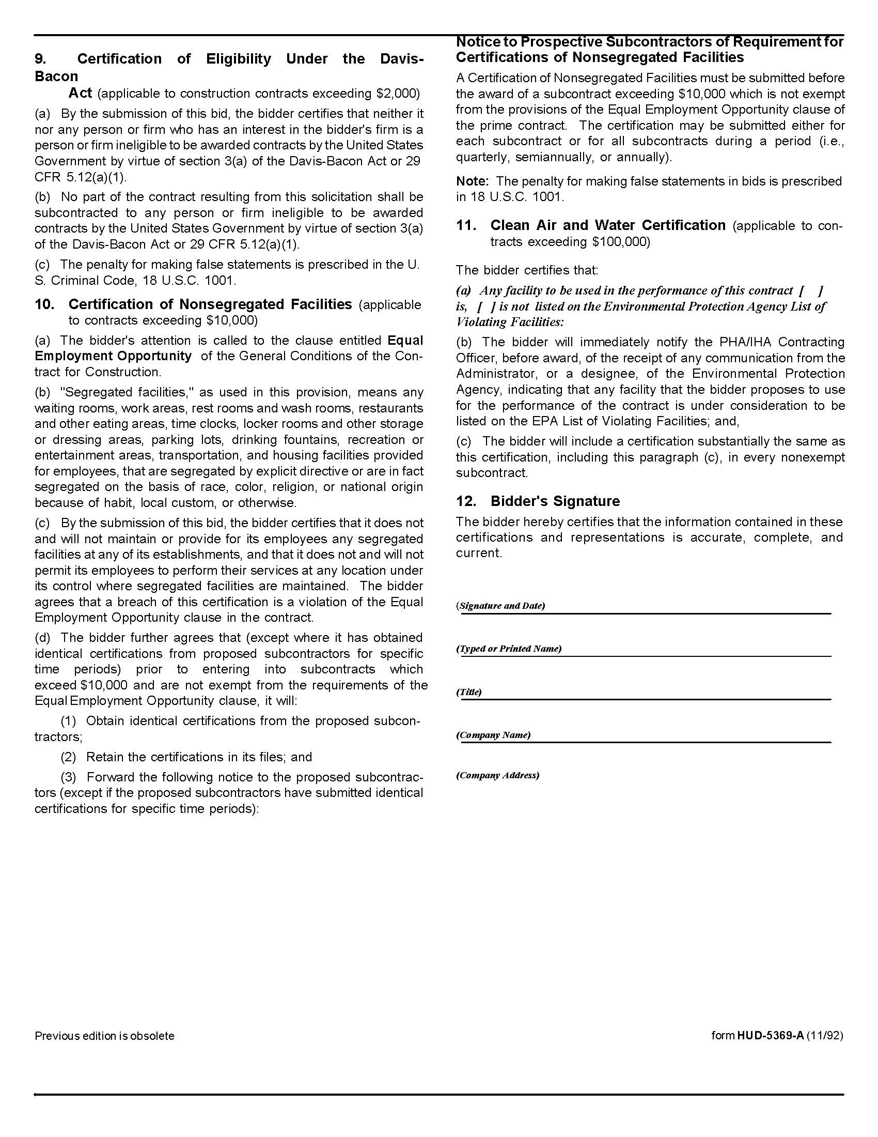

## Appliances (as needed) Q1804

## Solicitation Document D Pricing

Supplier: \_\_\_\_\_\_\_\_\_\_\_\_\_\_\_\_\_\_\_\_\_\_\_\_\_\_\_\_\_\_\_\_\_\_\_\_\_\_\_\_\_\_\_\_\_\_\_\_\_\_\_\_\_\_\_\_\_\_\_\_\_\_\_\_\_\_\_\_\_\_\_\_\_

**Suppliers are to submit specification sheets for the models bid.**

|  |  |  |  |  |  |  |
| --- | --- | --- | --- | --- | --- | --- |
| **DISHWASHER BASIC** | | | | **PRICE EACH** | | |
| **BRAND** | **MODEL**  **NUMBER** | **SIZE/NOTES** | **ENERGY**  **STAR**  **COMPLIANT** | **5 to 25** | **26 to 100** | **101 +** |
|  |  |  | YES  NO  N/A | $ | $ | $ |
| **DISHWASHER UPGRADE 1** | | | |  |  |  |
|  |  |  | YES  NO  N/A | $ | $ | $ |
| **DISHWASHER UPGRADE 2** | | | |  |  |  |
|  |  |  | YES  NO  N/A | $ | $ | $ |
| **DISHWASHER HANDICAP 1** | | | |  |  |  |
|  |  |  | Yes  No  NA | $ | $ | $ |

**Appliances (as needed) Q1804**

**Solicitation Document D Pricing - Continued**

Supplier: \_\_\_\_\_\_\_\_\_\_\_\_\_\_\_\_\_\_\_\_\_\_\_\_\_\_\_\_\_\_\_\_\_\_\_\_\_\_\_\_\_\_\_\_\_\_\_\_\_\_\_\_\_\_\_\_\_\_\_\_\_\_\_\_\_\_\_\_\_\_\_\_\_

**Suppliers are to submit specification sheets for the models bid.**

|  |  |  |  |  |  |  |
| --- | --- | --- | --- | --- | --- | --- |
| **STANDARD ELECTRIC RANGE – TYPE 1/STYLE 1** | | | | **PRICE EACH** | | |
| **BRAND** | **MODEL**  **NUMBER** | **SIZE/NOTES** | **ENERGY**  **STAR**  **COMPLIANT** | **5 to 25** | **26 to 100** | **101 +** |
|  |  | 20/21 inch | Yes  No  NA | $ | $ | $ |
|  |  | 24 inch | Yes  No  NA | $ | $ | $ |
|  |  | 30 inch | Yes  No  NA | $ | $ | $ |
|  |  | 36 inch | Yes  No  NA | $ | $ | $ |
| **ELECTRIC RANGE UPGRADE 1 - BLACK** | | | | **PRICE EACH** | | |
| **BRAND** | **MODEL**  **NUMBER** | **SIZE/NOTES** | **ENERGY**  **STAR**  **COMPLIANT** | **5 to 25** | **26 to 100** | **101 +** |
|  |  | 30 inch | Yes  No  NA | $ | $ | $ |
| **ELECTRIC RANGE ELDERLY/HANDICAP 1** | | | | **PRICE EACH** | | |
| **BRAND** | **MODEL**  **NUMBER** | **SIZE/NOTES** | **ENERGY**  **STAR**  **COMPLIANT** | **5 to 25** | **26 to 100** | **101 +** |
|  |  | 20/21 inch | Yes  No  NA | $ | $ | $ |

**Appliances (as needed) Q1804**

**Solicitation Document D Pricing - Continued**

Supplier: \_\_\_\_\_\_\_\_\_\_\_\_\_\_\_\_\_\_\_\_\_\_\_\_\_\_\_\_\_\_\_\_\_\_\_\_\_\_\_\_\_\_\_\_\_\_\_\_\_\_\_\_\_\_\_\_\_\_\_\_\_\_\_\_\_\_\_\_\_\_\_\_\_

**Suppliers are to submit specification sheets for the models bid.**

|  |  |  |  |  |  |  |
| --- | --- | --- | --- | --- | --- | --- |
| **ELECTRIC RANGE ELDERLY/HANDICAP 2** | | | | **PRICE EACH** | | |
| **BRAND** | **MODEL**  **NUMBER** | **SIZE/NOTES** | **ENERGY**  **STAR**  **COMPLIANT** | **5 to 25** | **26 to 100** | **101 +** |
|  |  | 24 inch | Yes  No  NA | **$** | **$** | **$** |
| **ELECTRIC RANGE ELDERLY/HANDICAP 3** | | | | **PRICE EACH** | | |
| **BRAND** | **MODEL**  **NUMBER** | **SIZE/NOTES** | **ENERGY**  **STAR**  **COMPLIANT** | **5 to 25** | **26 to 100** | **101 +** |
|  |  | 30 inch | Yes  No  NA | $ | $ | $ |
| **STANDARD GAS RANGE** | | | | **PRICE EACH** | | |
| **BRAND** | **MODEL**  **NUMBER** | **SIZE/NOTES** | **ENERGY**  **STAR**  **COMPLIANT** | **5 to 25** | **26 to 100** | **101 +** |
|  |  | 20/21 inch | Yes  No  NA | $ | $ | $ |
| **GAS RANGE W/ 9 VOLT BATTERY INGNITION SYSTEM - WHITE** | | | | **PRICE EACH** | | |
| **BRAND** | **MODEL**  **NUMBER** | **SIZE/NOTES** | **ENERGY**  **STAR**  **COMPLIANT** | **5 to 25** | **26 to 100** | **101 +** |
|  |  | 30 inch | Yes  No  NA | $ | $ | $ |

**Appliances (as needed) Q1804**

**Solicitation Document D Pricing - Continued**

Supplier: \_\_\_\_\_\_\_\_\_\_\_\_\_\_\_\_\_\_\_\_\_\_\_\_\_\_\_\_\_\_\_\_\_\_\_\_\_\_\_\_\_\_\_\_\_\_\_\_\_\_\_\_\_\_\_\_\_\_\_\_\_\_\_\_\_\_\_\_\_\_\_\_\_

**Suppliers are to submit specification sheets for the models bid.**

|  |  |  |  |  |  |  |
| --- | --- | --- | --- | --- | --- | --- |
| **MICROWAVE 1 – COUNTER TOP** | | | | **PRICE EACH** | | |
| **BRAND** | **MODEL**  **NUMBER** | **SIZE/NOTES** | **ENERGY**  **STAR**  **COMPLIANT** | **5 to 25** | **26 to 100** | **101 +** |
|  |  |  | Yes  No  NA | $ | $ | $ |
|  |  |  | Yes  No  NA | $ | $ | $ |
| **MICROWAVE 2 – COUNTER TOP** | | | | **PRICE EACH** | | |
| **BRAND** | **MODEL**  **NUMBER** | **SIZE/NOTES** | **ENERGY**  **STAR**  **COMPLIANT** | **5 to 25** | **26 to 100** | **101 +** |
|  |  |  | Yes  No  NA | $ | $ | $ |
|  |  |  | Yes  No  NA | $ | $ | $ |
| **MICROWAVE 3 - SPACEMAKER** | | | | **PRICE EACH** | | |
| **BRAND** | **MODEL**  **NUMBER** | **SIZE/NOTES** | **ENERGY**  **STAR**  **COMPLIANT** | **5 to 25** | **26 to 100** | **101 +** |
|  |  |  | Yes  No  NA | $ | $ | $ |
|  |  |  | Yes  No  NA | $ | $ | $ |

**Appliances (as needed) Q1804**

**Solicitation Document D Pricing - Continued**

Supplier: \_\_\_\_\_\_\_\_\_\_\_\_\_\_\_\_\_\_\_\_\_\_\_\_\_\_\_\_\_\_\_\_\_\_\_\_\_\_\_\_\_\_\_\_\_\_\_\_\_\_\_\_\_\_\_\_\_\_\_\_\_\_\_\_\_\_\_\_\_\_\_\_\_

**Suppliers are to submit specification sheets for the models bid.**

|  |  |  |  |  |  |  |
| --- | --- | --- | --- | --- | --- | --- |
| **MICROWAVE 4 - SPACEMAKER** | | | | **PRICE EACH** | | |
| **BRAND** | **MODEL**  **NUMBER** | **SIZE/NOTES** | **ENERGY**  **STAR**  **COMPLIANT** | **5 to 25** | **26 to 100** | **101 +** |
|  |  |  | Yes  No  NA | $ | $ | $ |
|  |  |  | Yes  No  NA | $ | $ | $ |
| **MICROWAVE 5 - SPACEMAKER** | | | | **PRICE EACH** | | |
| **BRAND** | **MODEL**  **NUMBER** | **SIZE/NOTES** | **ENERGY**  **STAR**  **COMPLIANT** | **5 to 25** | **26 to 100** | **101 +** |
|  |  |  | Yes  No  NA | $ | $ | $ |
|  |  |  | Yes  No  NA | $ | $ | $ |

**Appliances (as needed) Q1804**

**Solicitation Document D Pricing - Continued**

Supplier: \_\_\_\_\_\_\_\_\_\_\_\_\_\_\_\_\_\_\_\_\_\_\_\_\_\_\_\_\_\_\_\_\_\_\_\_\_\_\_\_\_\_\_\_\_\_\_\_\_\_\_\_\_\_\_\_\_\_\_\_\_\_\_\_\_\_\_\_\_\_\_\_\_

**Suppliers are to submit specification sheets for the models bid.**

|  |  |  |  |  |  |  |
| --- | --- | --- | --- | --- | --- | --- |
| **RANGE HOOD 1** | | | | **PRICE EACH** | | |
| **BRAND** | **MODEL**  **NUMBER** | **SIZE/NOTES** | **ENERGY**  **STAR**  **COMPLIANT** | **5 to 25** | **26 to 100** | **101 +** |
|  |  |  | Yes  No  NA | $ | $ | $ |
|  |  |  | Yes  No  NA | $ | $ | $ |
| **RANGE HOOD 2** | | | | **PRICE EACH** | | |
| **BRAND** | **MODEL**  **NUMBER** | **SIZE/NOTES** | **ENERGY**  **STAR**  **COMPLIANT** | **5 to 25** | **26 to 100** | **101 +** |
|  |  |  | Yes  No  NA | $ | $ | $ |
|  |  |  | Yes  No  NA | $ | $ | $ |

**Appliances (as needed) Q1804**

**Solicitation Document D Pricing - Continued**

Supplier: \_\_\_\_\_\_\_\_\_\_\_\_\_\_\_\_\_\_\_\_\_\_\_\_\_\_\_\_\_\_\_\_\_\_\_\_\_\_\_\_\_\_\_\_\_\_\_\_\_\_\_\_\_\_\_\_\_\_\_\_\_\_\_\_\_\_\_\_\_\_\_\_\_

**Suppliers are to submit specification sheets for the models bid.**

|  |  |  |  |  |  |  |  |  |  |  |  |  |
| --- | --- | --- | --- | --- | --- | --- | --- | --- | --- | --- | --- | --- |
| **REFRIGERATOR BASIC** | | | | | | | | **PRICE EACH** | | | | |
| **BRAND** | **MODEL**  **NUMBER** | | **SIZE/NOTES** | | **ENERGY**  **STAR**  **COMPLIANT** | | | **5 to 25** | | **26 to 100** | | **101 +** |
|  |  | | 14.6 cu. feet | | Yes  No  NA | | | **$** | | **$** | | **$** |
| **REFRIGERATOR UPGRADE 1** | | | | | | | | **PRICE EACH** | | | | |
| **BRAND** | **MODEL**  **NUMBER** | | **SIZE/NOTES** | | **ENERGY**  **STAR**  **COMPLIANT** | | | **5 to 25** | | **26 to 100** | | **101 +** |
|  |  | | 16.6 cu. feet | | Yes  No  NA | | | $ | | $ | | $ |
| **REFRIGERATOR ELDERLY/HANDICAP 1** | | | | | | | **PRICE EACH** | | | | | |
| **BRAND** | | **MODEL**  **NUMBER** | | **SIZE/NOTES** | | **ENERGY**  **STAR**  **COMPLIANT** | **5 to 25** | | **26 to 100** | | **101 +** | |
|  | |  | | 18.2 cu. feet | | Yes  No  NA | $ | | $ | | $ | |
| **REFRIGERATOR ELDERLY/HANDICAP 2** | | | | | | | **PRICE EACH** | | | | | |
| **BRAND** | **MODEL**  **NUMBER** | | | **SIZE/NOTES** | | **ENERGY**  **STAR**  **COMPLIANT** | **5 to 25** | | **26 to 100** | | **101 +** | |
|  |  | | | 23.2 cu. feet | | Yes  No  NA | $ | | $ | | $ | |

**Appliances (as needed) Q1804**

**Solicitation Document D Pricing - Continued**

Supplier: \_\_\_\_\_\_\_\_\_\_\_\_\_\_\_\_\_\_\_\_\_\_\_\_\_\_\_\_\_\_\_\_\_\_\_\_\_\_\_\_\_\_\_\_\_\_\_\_\_\_\_\_\_\_\_\_\_\_\_\_\_\_\_\_\_\_\_\_\_\_\_\_\_

**Suppliers are to submit specification sheets for the models bid.**

|  |  |  |  |  |
| --- | --- | --- | --- | --- |
| **ITEM** | **MODEL/BRAND** | **5 to 25** | **26 to 100** | **101 +** |
| 3-Prong Range Cord  (equal to Utilitech Model UTR628106) |  | $ | $ | $ |
| 4-Prong Range Cord  (equal to Utilitech Model UTR628206) |  | $ | $ | $ |

OPTIONS

|  |  |
| --- | --- |
| Cost for Removing and Properly Disposing of Old Refrigerators | $ |
| Cost for Installing New Refrigerators | $ |
| Cost for Removing and Properly Disposing of Old Ranges | $ |
| Cost for Installing New Ranges | $ |
| Cost for Removing and Properly Disposing of Old Dishwashers | $ |
| Cost for Installing New Dishwashers | $ |

OTHER

|  |  |
| --- | --- |
| Minimum Dollar Value for Orders (if applicable) | $ |
| Entities wishing to purchase less than five units will be charged at the 5-25 unit cost, plus a shipping charge of | $  Per unit shipping charge |
| Firestop Canisters | $ |

## Appliances (as needed) Q1804

## Appendix I TAHRA Member Listing

|  |  |  |  |  |  |
| --- | --- | --- | --- | --- | --- |
| ENTITY | EXECUTIVE DIRECTOR | EMAIL | ADDRESS | PHONE | NUMBER OF UNITS |
| Athens Housing  Authority | Ross Dodson | [ross@athenstnha.com](mailto:ross@athenstnha.com) | P. O. Box 928 Athens, TN 37301 | 423.745.0341 | 441 |
| Bolivar Housing Authority | Michael A. Miller | [bhahhs@bellsouth.net](mailto:bhahhs@bellsouth.net) | 621 Hatchie Haven Bolivar, TN 38008 | 731.658.3419 | 119 |
| Bristol Housing Authority | Steve Scyphers | [jss@bthra.org](mailto:jss@bthra.org) | 204 Bluff City Hwy. Bristol, TN 37621 | 423.274.8150 | 354 |
| Brownsville Housing Authority | Brenda Lonon | [blonon@brownsvilleha.org](mailto:blonon@brownsvilleha.org) | P. O. Box 194, 254 Anderson Ave. Brownsville, TN 38012 | 731.772.0274 | 135 |
| Chattanooga Housing Authority | Debbie Chadwick | [dchadwick@chahousing.org](mailto:dchadwick@chahousing.org%20) | P. O. Box 1486 801 N. Holtzclaw Ave. (37404) Chattanooga,TN 37401 | 423.668.2374 | 2,672 |
| Clarksville Housing Authority | Wanda B. Mills | [wmills@clarksvillehousing.org](mailto:wmills@clarksvillehousing.org) | P. O. Box 603, 721 Richardson St. Clarksville, TN 37041 | 931.647.2303 | 508 |
| Cleveland  Housing Authority | Paul A. Dellinger | [paul@clevelandhousingauthority.org](mailto:paul@clevelandhousingauthority.org) | P. O. Box 2846, 450 Walker St., NE Cleveland, TN 37320 | 423.479.9659 EXT 109 | 420 |
| Clinton  Housing Authority | John H. Greer | [clintonha@bellsouth.net](mailto:clintonha@bellsouth.net) | 825 McAdoo Street Clinton, TN 37716 | 865.457.9692 | 150 |
| Columbia Housing & Redevelopment Corp. | Trent Ogilvie | [trent@chrc-tn.org](mailto:trent@chrc-tn.org) | 101 Penny Ave. Columbia, TN 38401 | 931.388.5203 EXT 224 | 296 |
| Covington Housing Authority | Christi Billings | [covhouse@bellsouth.net](mailto:covhouse@bellsouth.net) | P. O. Box 88, 1701 Shoaf St. Covington, TN 38019 | 901.476.6135 | 246 |
| Crossville Housing Authority | Don Alexander | [dra@crossvillehousing.org](mailto:dra@crossvillehousing.org) | P. O. Box 425, 67 Irwin Ave. Crossville, TN 38557 | 931.484.2990 | 757 |
| Dayton  Housing Authority | Lisa Bonadio | [lbonidao@daytonhousingauthority.org](mailto:lbonidao@daytonhousingauthority.org) | P. O. Box 257, 270 Railroad St. Dayton, TN 37321 | 423.775.1871 EXT 227 | 342 |
| Dickson Housing Authority | Buford Reed, Jr. | [booty@dichsonhousing.com](mailto:booty@dichsonhousing.com) | 333 Martin Luther King Jr. Blvd. Dickson, TN 37055 | 615.446.4708 | 164 |
| Ducktown  Housing Authority | Sheryl Miller | [ducktownhousing@gmail.com](mailto:ducktownhousing@gmail.com) | P. O. Box 214 Ducktown, TN 37326 | 423.496.3546 |  |
| Dyersburg  Housing Authority | Paula Ledford | [dhapl@ecsis.net](mailto:dhapl@ecsis.net) | P. O. Box 824, 541 Hike Ave. Dyersburg, TN 38025 | 731.285.6771 | 502 |
| Elizabethton  Housing Authority | Kelly Geagley | [ehdatn@gmail.com](mailto:ehdatn@gmail.com) | P. O. Box 637 Elizabethton, TN 37644 | 423.543.3571 | 326 |
| Erin  Housing Authority | Melinda Deason | [erinha@peoplestel.net](mailto:erinha@peoplestel.net) | P. O. Box 384, 44 Griffin Dr. Erin, TN 37061 | 931.289.4261 | 60 |
| Erwin  Housing Authority | Lori Rice | [lori@erwinhousing.comcastbiz.net](mailto:lori@erwinhousing.comcastbiz.net) | 750 Carolina Ave., Building 100 Erwin, TN 37650 | 423.743.5231 | 73 |
| Etowah  Housing Authority | Carolyn Jonnson | [cjeha@comcast.net](mailto:cjeha@comcast.net) | 400 Sunset Dr. Etowah, TN 37331 | 423.263.2674 | 136 |
| Fayetville  Housing Authority | Jimmy Bills | [fayhous@fpunet.com](mailto:fayhous@fpunet.com) | P. O. Box 999 Fayetville, TN 37334 | 931.433.1587 | 276 |
| Franklin Co. Consolidated  Housing Authority | Lydia McBee | [lmfccha@bellsouth.net](mailto:lmfccha@bellsouth.net) | P. O. Box 502 Winchester, TN 37398 | 931.967.0344 | 248 |
| Franklin  Housing Authority | Derwin Jackson | [djackson@franklinhousingauthority.com](mailto:djackson@franklinhousingauthority.com) | 200 Spring St. Franklin, TN 37064 | 615.794.1247 | 273 |
| Gallatin  Housing Authority | Michael Bates | [gallhsg@comcast.net](mailto:gallhsg@comcast.net) | 401 N. Boyers Ave. Gallatin, TN 37066 | 615.452.1661 | 389 |
| Gallaway  Housing Authority | Brian Harris | [brian@martinhousing.org](mailto:brian@martinhousing.org) | 200 Jackson St. Arlington, TN 38002 | 901.867.8101 | 60 |
| Greeneville  Housing Authority | Rebecca Moyer | [grneha@comcast.net](mailto:grneha@comcast.net) | P. O. Box 279, 100 Cox Circle Greeneville, TN 37743 | 423.638.3111 | 325 |
| Grundy  Housing Authority | Derryl Graham | [dgraham@blomand.net](mailto:dgraham@blomand.net) | 187 Raulston St. Monteagle, TN 37356 | 931.924.2496 | 110 |
| Harriman  Housing Authority | Amy Hall | [ahall@harrimanhsg.org](mailto:ahall@harrimanhsg.org ) | 924 Sewanee St. Harriman, TN 37748 | 865.882.9636 | 324 |
| Hartsville  Housing Authority | Kim Satterfield | [hartsvha@bellsouth.net](mailto:hartsvha@bellsouth.net) | P. O. Box 44, 212 Rogers St. Hartsville, TN 37074 | 615.374.3959 | 34 |
| Highland Residential  Services (formerly Cookeville HA | Chris Cassetty Director of Operations | [ccassetty@highlandsrs.com](mailto:ccassetty@highlandsrs.com) | P. O. Box 400 Cookeville,TN 38501 | 931.526.9793 | 529 |
| Hohenwald  Housing Authority | Terry Bunch | [terry@hohenwaldhousing.com](mailto:terry@hohenwaldhousing.com) | 107 Allison Ave. Hohenwald, TN 38462 | 931.796.3642 | 116 |
| Humboldt  Housing Authority | Patricia Taylor | [humhouse@bellsouth.net](mailto:humhouse@bellsouth.net) | 3532 Seymour Loop Humboldt, TN 38343 | 731.784.9722 | 232 |
| Huntingtondon  Housing Authority | Denelda Price | [director@huntingdonhousing.org](mailto:director@huntingdonhousing.org) | 433 Hillcourt Circle Huntingdon, TN 38344 | 731.986.4442 | 148 |
| Jackson  Housing Authority | C. Winston Henning | [whenning@jacksonha.com](mailto:whenning@jacksonha.com) | P. O. Box 3188, 125 Preston St. Jackson, TN 38303 | 731.422.1671 EXT 103 | 982 |
| Jefferson City  Housing Authority | Keith Godwin | [1jcha@bellsouth.net](mailto:1jcha@bellsouth.net) | 942 East Ellis St. Jefferson City, TN 37760 | 865.475.2064 | 199 |
| Jellico  Housing Authority | Crystal Creekmore | [jellicoha@bellsouth.net](mailto:jellicoha@bellsouth.net) | P. O. Box 240 Jellico, TN 37762 | 423.784.8809 | 122 |
| Johnson City  Housing Authority | Richard McClain | [richardm@jchousing.org](mailto:richardm@jchousing.org) | 901 Pardee St.  Johnson City, TN 37601 | 423.232.4784 | 752 |
| Kingsport Housing & Redevelopment Authority | Terry W. Cunningham | [khra@kingsporthousing.org](mailto:khra@kingsporthousing.org) | P. O. Box 44, 906 E. Sevier Ave. Kinsgport, TN 37662 | 423.392.2513 | 529 |
| Knoxville's Community Development Corp. KCDC | Terry  McKee | [tmckee@kcdc.org](mailto:tmckee@kcdc.org) | 901 N. Broadway Knoxville, TN 37917 | 865.403.1100 | 3,870 |
| Lafayette  Housing Authority | Lisa Gentry | [lafhouse@nctc.com](mailto:lafhouse@nctc.com) | 613 Dycus Circle Lafayette, TN 37083 | 615.666.2140 | 102 |
| LaFollette  Housing Authority | John Snodderly | [john@lafollettehousing.org](mailto:john@lafollettehousing.org) | P. O. Box 392 LaFollette, TN 37766 | 423.562.2261 | 1,116 |
| Lawrenceburg  Housing Authority | Eddy Casteel | [houseaut@lawrenceburgha.org](mailto:houseaut@lawrenceburgha.org) | P. O. Drawer C, 1020 Smith Ave. Lawrenceburg, TN 38464 | 931.762.7532 | 303 |
| Lebanon  Housing Authority | Patrick Johnson | [pjohnson@lhatn.org](mailto:pjohnson@lhatn.org) | 49 Upton Heights Lebanon, TN 37087 | 615.444.1872 EXT 117 | 354 |
| Lenoir City  Housing Authority | Mary Sue Jordan | [msjordan@lcityha.org](mailto:msjordan@lcityha.org) | 101 Oakwood Dr. Lenoir City,TN 37771 | 865.986.8707 | 170 |
| Lewisburg  Housing Authority | Ronald Robinson | [lha@tnweb.com](mailto:lha@tnweb.com) | 744 Bark St. Lewisburg, TN 37091 | 931.359.4517 | 220 |
| Lexington  Housing Authority | Melba J. Johnson | [melbalha@gmail.com](mailto:melbalha@gmail.com) | 100 Willow Court Lexington, TN 38351 | 731.968.7506 | 120 |
| Livingston  Housing Authority | Ken Mabry | [livhouseauth@twlakes.net](mailto:livhouseauth@twlakes.net) | P. O. Box 98, East 7th St. Livingston, TN 38570 | 931.823.6423 | 65 |
| Loudon  Housing Authority | Lori Everett | [lhalori@bellsouth.net](mailto:lhalori@bellsouth.net) | P. O. Box 425, 124 Pathkiller Trail Loudon, TN 37774 | 865.458.2061 | 121 |
| Manchester  Housing Authority | Nancy Huddleston | [mha@cafes.net](mailto:mha@cafes.net) | 710 Butler Circle Manchester, TN 37355 | 931.728.2596 | 166 |
| Martin  Housing Authority | Brian Harris | [brian@martinhousing.org](mailto:brian@martinhousing.org) | 134 E. Heights Dr. Martin, TN 38237 | 731.587.3186 | 433 |
| Maryville  Housing Authority | Nancy Burnette | [nburnette@mhatn.com](mailto:nburnette@mhatn.com) | 311 Atlantic Ave. Maryville, TN 37801 | 865.983.4958 | 517 |
| McKenzie  Housing Authority | Barbara Cooper | [coopermha@bellsouth.net](mailto:coopermha@bellsouth.net) | 22 McDonald Ave. McKenzie, TN 38201 | 731.352.5335 | 148 |
| McMinnville  Housing Authority | Patricia Basham | [mmha@blomand.net](mailto:mmha@blomand.net) | 301 Hardaway St. McMinnville, TN 37110 | 931.473.3286 | 422 |
| Memphis  Housing Authority | Dorian Jenkins | [swilkins@mhanewday.com](mailto:swilkins@mhanewday.com) | P. O. Box 3664, 700 Adams Ave. Memphis, TN 38103 | 901.544.1102 | 2,990 |
| Metropolotin (Nashville) Development & Housing  Agency (MDHA) | Rita James | [rjames@nashville-mdha.org](mailto:rjames@nashville-mdha.org) | 701 South 6th St. Nashville, TN 37206 | 615.252.8412 | 6129 |
| Milan  Housing Authority | Mark A. Dodson | [tn31@milanhousing.org](mailto:tn31@milanhousing.org) | 1000 Northside Terrace Milan, TN 38358 | 731.686.8571 | 100 |
| Millington  Housing Authority | Tanya Martchek | [themha@rittermail.com](mailto:themha@rittermail.com) | P. O. Box 55, 4888 Bill Knight Ave. Millington, TN 38083 | 901.872.3677 | 90 |
| Morristown  Housing Authority | Marilyn J. Medley | [mmedley@morristownpha.org](mailto:mmedley@morristownpha.org) | P. O. Box 497, 600 Sulphur Springs Rd. Morristown, TN 37815 | 423.586.5115 | 676 |
| Mt. Pleasant  Housing Authority | Dawn Hudson | [mphauth@bellsouth.net](mailto:mphauth@bellsouth.net) | 138 Thomas Circle Mt. Pleasant, TN 38474 | 931.379.5811 | 116 |
| Murfreesboro  Housing Authority | Thomas Rowe | [trowe@mha-tn.org](mailto:trowe@mha-tn.org) | 415 N. Maple St. Murfreesboro, TN 37130 | 615.893.9414 | 430 |
| Newbern  Housing Authority | Jane Norsworthy | [jnorsworthy@aeneas.net](mailto:jnorsworthy@aeneas.net) | P. O. Box 100 Newbern, TN 38059 | 731.627.2142 | 145 |
| Newport  Housing Authority | Charlie Boggan | [cwbogan4nha@newporttnhousing.com](mailto:cwbogan4nha@newporttnhousing.com) | 440 Lennon Circle Newport, TN 37821 | 423.623.1575 | 400 |
| Oak Ridge   Housing Authority | James A. Carson | [jacarson@orha.net](mailto:jacarson@orha.net) | 10 Van Hicks Lane Oak Ridge, TN 37830 | 865.482.1006 | 128 |
| Oliver Springs  Housing Authority | Karen Leffew | [oshousing@aol.com](mailto:oshousing@aol.com) | 131 Brittain Village Oliver Springs, TN 37840 | 865.435.1711 | 113 |
| Paris  Housing Authority | Lisa Wimberley | [parhsing@bellsouth.net](mailto:parhsing@bellsouth.net) | 917 Minor St. Paris, TN 38242 | 731.642.4451 | 196 |
| Parsons-Decaturville  Housing Authority | Mecca Derre | [meccapdha@gmail.com](mailto:meccapdha@gmail.com) | 155 Miller St., Unit 301C Parsons, TN 38363 | 731.847.2638 | 68 |
| Portland  Housing Authority | Sabrina Woodard | [ptldhsgdirector@gmail.com](mailto:ptldhsgdirector@gmail.com) | P. O. Box 37, 107 Potts Ave. Portland, TN 37148 | 615.325.4559 | 120 |
| Pulaski  Housing Authority | Vivian Gordon | [viviango@pulaskihousing.com](mailto:viviango@pulaskihousing.com) | 2006 Garden Meadow Drive Pulaski, TN 38478 | 931.363.6525 | 209 |
| Ripley  Housing Authority | Justin Jones | [jjones@ripleyha.net](mailto:jjones@ripleyha.net) | 101 Northcrest Ripley, TN 38063 | 731.635.1901 EXT 28 | 265 |
| Rockwood  Housing Authority | Jill Jiles-Everhart | [jjeverhart@bellsouth.net](mailto:jjeverhart@bellsouth.net) | 320 Carpenter St. Rockwood, TN 37854 | 865.354.9841 | 159 |
| Rogersville  Housing Authority | Rebecca Wolf | [rhabecky@rogersvillehousing.net](mailto:rhabecky@rogersvillehousing.net) | 902 Locust St. Rogersville,TN 37857 | 423.272.8540 | 204 |
| Savannah  Housing Authority | C. Hardin Hughes | [hardin@savhousing.com](mailto:hardin@savhousing.com) | 80 Jefferson St. Savannah, TN 38372 | 731.925.2020 | NO ANSWER |
| Sevierville  Housing Authority | Ronald Franklin | [sevshng@bellsouth.net](mailto:sevshng@bellsouth.net) | 500 Leo Sharp Road Sevierville, TN 37862 | 865.453.8500 | 245 |
| Shelbyville  Housing Authority | William Hershel Thrasher | [whthrashersha@bellsouth.net](mailto:whthrashersha@bellsouth.net) | P. O. Box 560, 316 Templeton St. Shelbyville, TN 37160 | 931.684.1341 EXT 20 | 422 |
| Smithville  Housing Authority | Sharon Prater | [smthvhou@dtccom.net](mailto:smthvhou@dtccom.net) | P. O. Box 117, 415 Jackson St. Smithville, TN 37166 | 615.597.4140 EXT 3 | 182 |
| Smyrna  Housing Authority | Sean Lee | [sean\_lee@comcast.net](mailto:sean_lee@comcast.net) | 701 Stan Circle Smyrna, TN 37167 | 615.459.8866 | 736 |
| South Carthage  Housing Authority | Michael Bates |  | P. O. Box 197, 109 Hazel Drive Carthage, TN 37030 | 615.735.1940 | 70 |
| South Pittsburg  Housing Authority | Lisa Bradford | [sphalb@bellsouth.net](mailto:sphalb@bellsouth.net) | P. O. Box 231, 214 Elm Ave. South Pittsburg, TN 37380 | 423.837.6600 | 202 |
| Sparta  Housing Authority | Jim Payne | [jim@spartahousing.com](mailto:jim@spartahousing.com) | 300 Cragrock Drive Sparta, TN 38583 | 931.836.3357 | 162 |
| Springfield  Housing Authority | Seth Hudson | [springfield101@comcast.net](mailto:springfield101@comcast.net) | 808 Rose Hill Circle Springfield, TN 37172 | 615.384.4591 | NO ANSWER |
| Sweetwater  Housing Authority | Vicki Barnes | [vbarnes@sweetwaterhousing.com](mailto:vbarnes@sweetwaterhousing.com) | P. O. Box 88, #3 Valley View Village Dr. Sweetwater, TN 37874 | 423.337.6224 | 158 |
| Trenton  Housing Authority | Doug Lockard | [doug@trentonhousing.org](mailto:doug@trentonhousing.org) | 128 Burnett Drive Trenton, TN 38382 | 731.855.1231 | 210 |
| Tullahoma  Housing Authority | James H. (Jim) Rock | [tn024@bellsouth.net](mailto:tn024@bellsouth.net) | 2401 Cedar Lane Village Drive Tullahoma, TN 37388 | 931.455.9319 EXT 225 | 310 |
| Union City  Housing Authority | Gena Burden | [gena@uchousing.org](mailto:gena@uchousing.org) | 1409 E. Main St. Union City, TN 38261 | 731.885.1971 | 286 |
| Waverly  Housing Authority | Buford Reed | [booty@dicksonhousing.com](mailto:booty@dicksonhousing.com) | 35 W. Brookside Drive Waverly, TN 37185 | 931.296.2256 | 70 |
| Woodbury  Housing Authority | Pam P. Cunningham | [whatn@dtccom.net](mailto:whatn@dtccom.net) | 401 McFerrin St. Woodbury, TN 37190 | 615.563.5276 | 100 |