HIGHLANDS COUNTY
BOARD OF COUNTY COMMISSIONERS
Purchasing Division

FORMAL WRITTEN QUOTE (FWQ) REQUEST

FWQ Number: 18-014

The Highlands County Board of County Commissioners (HCBCC, County) is seeking quotations for the following products and/or services:

DEMOLITION AND REMOVAL OF THE HOME, REMOVE ALL TRASH AND DEBRIS FROM THE PROPERTY AND ABANDONED THE SEPTIC TANK AND LOCATED AT: 161 E. A. SMITH AVENUE, LAKE PLACID, FLORIDA 33852, C-07-37-30-040-0140-0050

GENERAL INFORMATION:
Requesting/End-User Department: | Zoning/Code Enforcement
Project Manager: | Beverly Singley
Submittal deadline: | 4 P.M. on June 25, 2018
Submit via: | Email to jasoto@hcbcc.org
Contact for questions: | Mrs. Jamee Soto (863-402-6526 or jasoto@hcbcc.org)
License requirement: | N/A
Insurance requirements: | Vendors may submit a certificate of insurance (Acord form showing the Highlands County Board of County Commissioners as the certificate holder) with their response to this Request or may submit with that Response a letter from a licensed insurance agent confirming that the vendor can be insured for the amounts required by paragraph 2.11 of this Request upon award. The awarded vendor must supply a certificate of insurance (Acord form showing the Highlands County Board of County Commissioners as the certificate holder) for the work to be performed or goods to be delivered pursuant to the purchase order issued pursuant to this Request before that purchase order will be issued.

GENERAL TERMS AND CONDITIONS:
By submitting a response to this Request for a FWQ, the vendor agrees to the following requirements, which shall be included in any purchase order issued pursuant to this Request:

The vendor shall hold all licenses and certifications and comply with all laws, ordinances, and regulations applicable to the work required to perform this purchase order. Any of the vendor’s personnel who perform services shall be lawfully licensed and certified. Damages, penalties, and fines imposed on County or vendor resulting from vendor’s failure to obtain and maintain required licenses and certifications shall be borne by vendor. All fees, permits, certifications, and licenses are the responsibility of the vendor and are included in the quoted price.

All reports, specifications, documents, plans, analyses, and other data and work product developed by vendor under this purchase order shall be delivered to County at any time upon its request and shall become the property of County upon payment of the agreed upon price without restrictions or limitations.

The vendor shall coordinate with the Requesting/User Department prior to commencing any and all work required to perform this purchase order.

Unless otherwise provided in this purchase order, upon satisfactory completion and delivery of all work or goods to the County pursuant to this purchase order, the County shall pay the amount of the purchase order to the vendor in accordance with Board’s Prompt Payment Policy and the Local Government Prompt Payment Act, Section 218.70 et. seq., Florida Statutes. Satisfactory completion shall be determined by Project Manager.
2.5 If any litigation is commenced between the parties concerning the work to be performed or goods to be delivered pursuant to this purchase order or the parties' respective rights and duties under this purchase order, the prevailing party may recover reasonable attorney’s fees and costs of litigation, in addition to other relief granted. Venue for any legal action shall lie in Highlands County, Florida, and any proceedings to enforce or interpret any provision of this purchase order shall be brought exclusively in a court of competent jurisdiction in Highlands County, Florida.

No delay or failure by either party to exercise any right, and no partial or single exercise of any right, shall constitute a waiver of that or any other right.

Rights and obligations shall be construed in accordance with and governed by the laws of the State of Florida.

Failure of the vendor to comply with the requirements of this purchase order shall constitute a breach of contract. A purchase order may be issued to the vendor that submitted the next lowest/available FWQ with the difference in price being paid by the vendor issued this purchase order.

The vendor shall not assign, transfer, convey, sublet or sell any portion of this purchase order or the performance thereof unless written consent is given, in advance, by the Project Manager.

The vendor shall be responsible for disposal of all material requiring disposal and shall show proof of disposal at an authorized landfill prior to submitting an invoice or other request for payment, if applicable.
2.11 Until final payment is received by the vendor from the County pursuant to this purchase order, the vendor shall maintain in force and effect the following insurance for the work to be performed or goods to be delivered pursuant to this purchase order:

Workers' Compensation – coverage must meet statutory limits in compliance with the Workers' Compensation Law of Florida. This policy must include Employer Liability with a limit $100,000 for each accident, $500,000 disease (policy limit) and $100,000 disease (each employee).

Commercial General Liability - coverage shall provide minimum limits of liability of $500,000 per occurrence Combined Single Limit for Bodily Injury and Property Damage, including coverage for:

* Premises/Operations * Products/Completed Operations

* Broad Form Contractual Liability * Independent Contractors

(c) Business Auto Liability, if applicable - coverage shall provide minimum limits of liability of $500,000 combined single limit per occurrence for bodily injury and property damage, including coverage for liability arising out of any auto, including owned, hired, and non-owned autos.

The vendor shall deliver a completed W-9 form to the County, within ten (10) days after the purchase order is issued, unless it already done so.

The vendor shall be prepared to start providing services within the time stated in this purchase order. Failure to complete the work or deliver goods as scheduled may result in written notice to the vendor terminating its right to proceed. Should the vendor be unable to complete the services or deliver the goods within the scheduled time, the County may use the services or goods provided by another vendor. The difference in the contracted price for the services or delivery of the goods and that paid the new vendor for the services or goods shall be charged to and paid by vendor to whom this purchase order was issued by set-off against any amount owed by the County to that vendor or, if none, shall be paid by that vendor to the County within twenty (20) days after being invoiced by the County.

The County is a political subdivision of the State of Florida and is not subject to federal excise tax or state sales or use tax. The vendor shall not add taxes of any kind to the cost of services or goods or invoice to or collect from the County any federal excise tax or state sales or use tax.
2.15 If by providing services to the County pursuant to this purchase order the vendor is a contractor, as defined by Section 119.0701, Florida Statutes, the vendor shall:
(a) Keep and maintain public records required by the County to perform the services.
(b) Upon request of the County’s custodian of public records, provide the County with a copy of the requested records or allow the records to be inspected or copied within a reasonable time at the cost that does not exceed the cost provided in Chapter 119, Florida Statutes, or as otherwise provided by law.
(c) Ensure that public records that are exempt or confidential and exempt from public records disclosure requirements are not disclosed except as authorized by law for the duration of the term of this contract and following competition of this contract if vendor does not transfer the records to the County.
(d) Upon competition of performance of services required by this purchase order, transfer to the County, at no cost, all public records in possession of vendor or keep and maintain public records required by the County to perform the services. If the vendor transfers all public records to the County upon competition of the performance of services required by this purchase order, the vendor shall destroy any duplicate public records that are exempt or confidential and exempt from public records disclosure requirements. If the vendor keeps and maintains public records upon completion of performance of services required by this purchase order, the vendor shall meet all applicable requirements for retaining public records. All records stored electronically must be provided to the County upon request from the County’s custodian of public records, in a format that is compatible with the information technology systems of the County.

IF THE CONTRACTOR HAS QUESTIONS REGARDING THE APPLICATION OF CHAPTER 119, FLORIDA STATUTES, TO THE CONTRACTOR’S DUTY TO PROVIDE PUBLIC RECORDS RELATING TO THIS CONTRACT, CONTACT THE CUSTODIAN OF PUBLIC RECORDS AT:

Gloria Rybinski
County Public Information Officer
Telephone Number: 863-402-6836
E-mail Address: grybinski@hcbcc.org
Mailing Address: 600 South Commerce Avenue
Sebring, FL 33870

REQUIREMENTS, DELIVERABLES AND QUALIFICATIONS
BASED ON ATTACHED, HIGHLANDS COUNTY BOARD OF COUNTY COMMISSIONERS (HCBCC) IS SEEKING A CONTRACT FOR THE DEMOLITION AND REMOVAL OF THE HOME, REMOVE ALL TRASH AND DEBRIS FROM THE PROPERTY AND ABANDONED THE SEPTIC TANK AND LOCATED AT: 161 E. A. SMITH AVENUE, LAKE PLACID, FLORIDA 33852, C-07-37-30-040-0140-0050

FORMS

Price sheet

Local Preference Affidavit
The Local Preference Policy can be viewed on the County’s website:
http://hcbcc.net/departments/office_of_administrative_services/general_services_purchasing/index.php

Women/Minority Business Enterprise Certification

(If applicable)

THE REMAINDER OF THIS PAGE WAS LEFT BLANK INTENTIONALLY

FORMAL WRITTEN QUOTE SUBMITTED BY:

IN RESPONSE TO: FWQ 18-014

VENDOR NAME: __________________________________________________________________
(The name entered here will be used to confirm the number of years in business on the Florida Department of State, Division of Corporation’s website (sunbiz.org). Please print the exact name of your business entity as it appears on its annual report filed with the Department of State or, if none, your name.)

ADDRESS: _________________________________________________

PHONE NUMBER: __________________________________________

FEIN or SOCIAL SECURITY NUMBER:

EMAIL: ___________________________________________________

DOCUMENTATION INCLUDED (Check if included):

W-9 FORM

ACCORD LIABILITY INSURANCE
or CONFIRMATION LETTER
(See Item 2.8 of the GENERAL Terms and Conditions for the required minimum coverage)

LOCAL PREFERENCE AFFIDAVIT
(If applicable)

WOMEN/MINORITY BUSINESS ENTERPRISE CERTIFICATION
(If applicable)

COPY OF LICENSE
(If applicable)

COST OF DEMOLITION & REMOVAL OF ALL DEBRIS: $___________________.

I HEREBY CERTIFY THAT I HAVE READ, I UNDERSTAND, AND I AGREE TO THE TERMS AND CONDITIONS OF FWQ 18-014.

AUTHORIZED REPRESENTATIVE’S SIGNATURE: ______________________________________________

AUTHORIZED REPRESENTATIVE’S NAME (Print): _____________________________________________

AUTHORIZED REPRESENTATIVE’S TITLE (Print): ______________________________________________

THIS “OFFICIAL” FORMS MUST BE COMPLETED AND USED IN SUBMITTING YOUR WRITTEN QUOTE. THE BOARD RESERVES THE RIGHT TO ACCEPT OR REJECT ANY OR ALL WRITTEN QUOTES OR ANY PARTS THEREOF.
LOCAL PREFERENCE AFFIDAVIT OF ELIGIBILITY
THIS FORM MUST BE SIGNED AND SWORN TO IN THE PRESENCE OF A NOTARY PUBLIC OR OTHER OFFICIAL AUTHORIZED TO ADMINISTER OATHS.

1. This sworn statement is submitted to
HIGHLANDS COUNTY BOARD OF COUNTY COMMISSIONERS

by
[Print individual's name and title]
for
[Print name of Company/Individual submitting sworn statement]

Whose business address is_______________________________________________________

(If applicable) its Federal Employer Identification Number (FEIN) is________________________

(If the entity has no FEIN, include the Social Security Number of the individual signing this

Sworn statement):_____________________________________________________________.

2. LOCAL PREFERENCE ELIGIBILITY
- Vendor/Individual has had a fixed office or distribution point located in and having a street address within Highlands County for at least twelve (12) months immediately prior to the issuance of the request for quotation, competitive bids or request for proposals by the County.

YES ______ NO ______

- Vendor/Individual holds business license required by the County, and/or if applicable, the Municipalities:
YES ______ NO ______

- Vendor/Individual employs at least one full-time employee, or two part-time employees whose primary residence is in Highlands County, or, if the business has no employees, the business shall be at least fifty (50) percent owned by one or more persons whose primary residence is in Highlands County.
YES ______ NO ______

I UNDERSTAND THAT THE SUBMISSION OF THIS FORM TO THE PUBLIC ENTITY IDENTIFIED IN PARAGRAPH 1 (ONE) ABOVE IS FOR THAT PUBLIC ENTITY ONLY AND, THAT THIS FORM SHALL BE CONSIDERED PUBLIC RECORD.

________________________________________________ [Signature and Date]

STATE OF ______________, COUNTY OF _______________________

Subscribed and sworn before me, the undersigned notary public on this ____ day of ___________, 20___.

_______________________ ______________________________
NOTARY PUBLIC SEAL Commission Expiration Date

G:\COUNTY\PURCHASING DEPT\Formal Written Quote Request - 120616.docx
161 E. A. SMITH AVENUE, LAKE PLACID, FLORIDA 33852
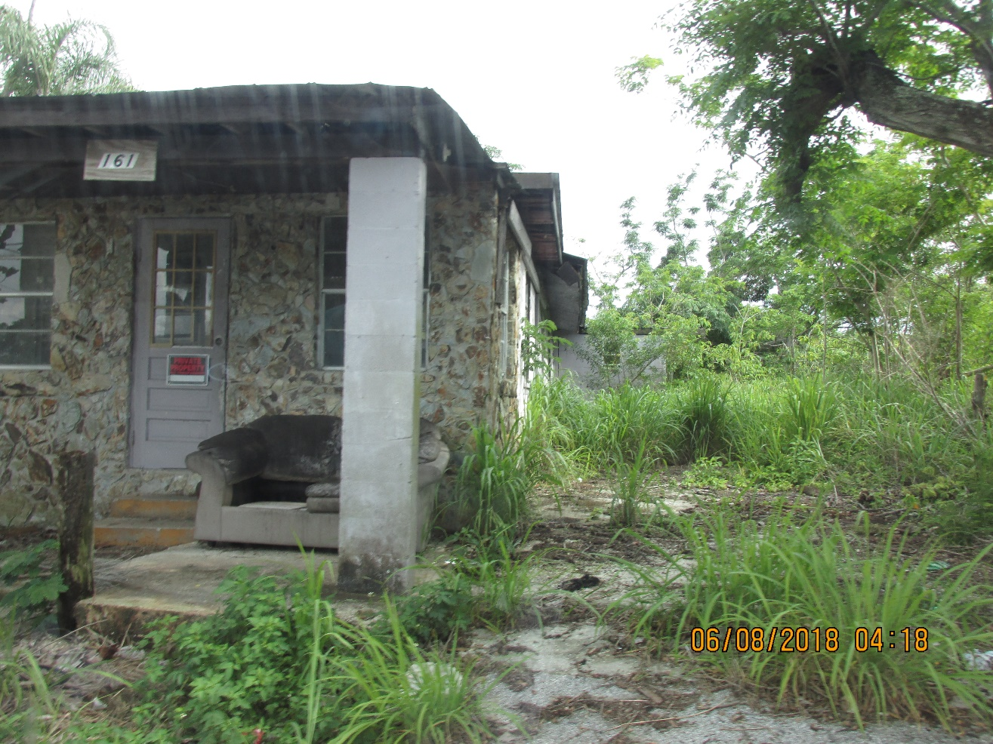

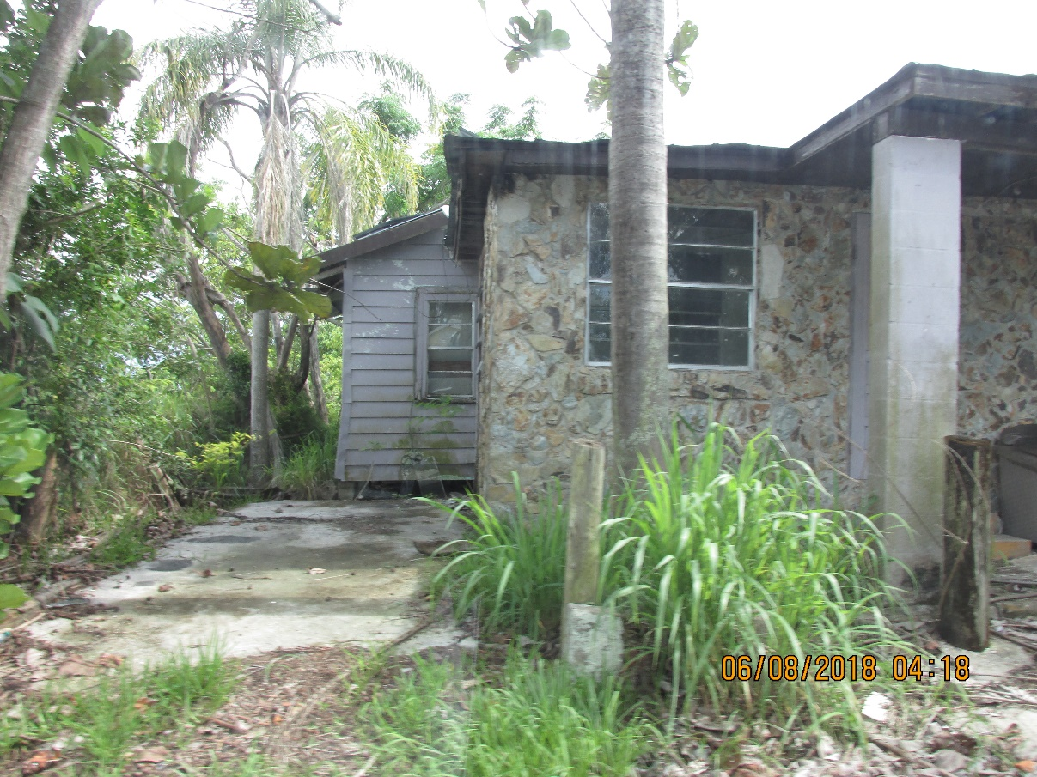

Map; 161 E. A. SMITH AVENUE, LAKE PLACID, FL 33852
