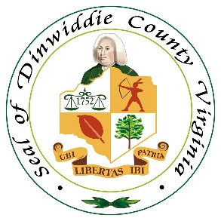

NOTICE OF INTENT TO AWARD

Date: May 9, 2023
Project #: 23-040523
Description: Grass Cutting and Lot Cleanup for Code Compliance

Upon finding them to have the best overall value, the County of Dinwiddie intents to award contracts to the following:
- Heaton’s Lawn Maintenance, Prince George, VA
- Oak Ridge Enterprise, Carson, VA
- Wyche’s Landscaping, Dinwiddie, VA

Award is pending approval by the Dinwiddie County Board of Supervisors on May 16, 2023.

Hollie R. Casey
Procurement Officer
Phone: (804) 469-4500 x 2150
hcasey@dinwiddieva.us

